**SZABADKAI MŰSZAKI SZAKFŐISKOLA**

**PROJEKTUM**

**Web programozás tantárgyból**

|  |  |
| --- | --- |
| **HALLGATÓ(K)**  **Mucsi Máté**  **26222061** | **MENTOR**  **prof. dr Zlatko Čović** |
| **SZABADKA, 2024.** | |

Tartalom

1. A feladatkör meghatározása 3

2. Kidolgozás 4

3. Az adatbázis struktúrája (MySQL Workbench) 5

4. A projekt működésének leírása 6

5. Felhasznált irodalom 7

# A feladatkör meghatározása

Röviden leírni a projekt feladatának a meghatározását. Adja meg a projekt webcímét.

A projektem címe, Kutyák Sétáltatása. Ebben a projektben, az emberek és háziállatuk életétének megkönnyítése van a fókuszban. Ez a weboldal egy egyszerű elérést nyújt bárkinek az internet, hogy kielégítsen egy kutya napi kifárasztását ha azt a gazdája nem tudja, vagy a gazda felkínálja, hogy szeretne sétálni a háziállatuk, ha ő maga nem tudja elvinni. Email cím és telefonszám elérhetőségek mindenhol fel lehet tüntetni, az összes felhasználó kedvéért.

# Kidolgozás

1. Az alap 5 oldal:

* A kezdőoldal, index.php:  
  <!DOCTYPE html>  
  <html lang="en">  
  <head>  
   <meta charset="UTF-8">  
   <link rel="stylesheet" href="https://cdn.jsdelivr.net/npm/bootstrap-icons@1.11.3/font/bootstrap-icons.min.css">  
   <link href="https://cdn.jsdelivr.net/npm/bootstrap@5.3.3/dist/css/bootstrap.min.css" rel="stylesheet" integrity="sha384-QWTKZyjpPEjISv5WaRU9OFeRpok6YctnYmDr5pNlyT2bRjXh0JMhjY6hW+ALEwIH" crossorigin="anonymous">  
   <script src="https://cdn.jsdelivr.net/npm/bootstrap@5.3.3/dist/js/bootstrap.bundle.min.js" integrity="sha384-YvpcrYf0tY3lHB60NNkmXc5s9fDVZLESaAA55NDzOxhy9GkcIdslK1eN7N6jIeHz" crossorigin="anonymous"></script>  
   <link  
   rel="stylesheet"  
   href="https://cdnjs.cloudflare.com/ajax/libs/animate.css/4.1.1/animate.min.css"  
   />  
   <link rel="preconnect" href="https://fonts.googleapis.com">  
   <link rel="preconnect" href="https://fonts.gstatic.com" crossorigin>  
   <link href="https://fonts.googleapis.com/css2?family=Madimi+One&display=swap" rel="stylesheet">  
   <link rel="stylesheet" type="text/css" href="CSS/indexCSS.css">  
   <title>Dogwalking</title>  
  </head>  
  <body>  
  <?php  
  require("db_config.php");  
  require 'functions.php';  
    
  try {  
   $sql_str = "";  
    
   $stmt = $pdo->prepare('SELECT u_fname, u_lname FROM users WHERE walk_switch = 1 AND u_rating >= 4 ORDER BY u_rating DESC LIMIT 5');  
   $stmt->execute();  
   $highestRatedWalkers = $stmt->fetchAll();  
    
   // Fetch top 5 most active walkers  
   $stmt2 = $pdo->prepare('SELECT u_fname, u_lname FROM users WHERE walk_switch = 1 ORDER BY activity_column DESC LIMIT 5'); // Replace `activity_column` with the appropriate column name for activity tracking  
   $stmt2->execute();  
   $mostActiveWalkers = $stmt2->fetchAll();  
    
  } catch(PDOException $e) {  
   echo "Connection failed: " . $e->getMessage();  
  }  
  ?>  
  <nav class="navbar navbar-expand-lg navbar-dark bg-dark">  
   <div class="container-fluid">  
   <a class="navbar-brand" href="#">Zoomies</a>  
   <button class="navbar-toggler" type="button" data-bs-toggle="collapse" data-bs-target="#navbarSupportedContent" aria-controls="navbarSupportedContent" aria-expanded="false" aria-label="Toggle navigation">  
   <span class="navbar-toggler-icon"></span>  
   </button>  
   <div class="collapse navbar-collapse" id="navbarSupportedContent">  
   <ul class="navbar-nav me-auto">  
   <li class="nav-item active">  
   <a class="nav-link" href="index.php">Homepage</a>  
   </li>  
   <li class="nav-item active">  
   <a class="nav-link" href="walkers.php">Our Walkers</a>  
   </li>  
   <li class="nav-item">  
   <a class="nav-link" href="dogs.php">Our Dogs</a>  
   </li>  
   <li class="nav-item">  
   <a class="nav-link" href="about.php">About Us</a>  
   </li>  
   <li class="nav-item">  
   <a class="nav-link" href="contact.php">Contact</a>  
   </li>  
   </ul>  
   <?php  
   session_start();  
    
   if(!isset($_SESSION['username'])){  
   echo '  
   <ul class="navbar-nav ms-auto">  
   <li class="nav-item">  
   <a class="nav-link" href="login.php">Login</a>  
   </li>  
   <li class="nav-item">  
   <a class="nav-link" href="register.php">Register</a>  
   </li>  
   </ul>  
   ';  
   }  
   else{  
   echo'  
   <ul class="navbar-nav ms-auto">  
   <li class="nav-item">  
   <a class="nav-link" href="user.php"><i class="bi bi-person-fill"></i>&nbsp;Profile</a>  
   </li>  
   </ul>';  
   }  
   ?>  
    
   </div>  
   </div>  
  </nav>  
  <div class = bod1>  
   <h2>Welcome to Zoomies<sup>TM</sup></h2><p class = "p1">Where you can search for people who will enable your pet to  
   live out their zzzzzzooming needs.</p>  
   <p class = "p1">If you want to help these people make their best friends happy, you can also sign up to be a  
   dog walker! </p>  
   <div class = "row dogimg">  
   <div class="col-1"></div>  
   <img src="Images/matt-nelson-aI3EBLvcyu4-unsplash.jpg" class = "col-lg-5 col-md-12 dg">  
   <img src="Images/camilo-fierro-z7rcwqCi77s-unsplash.jpg" class = "col-lg-5 col-md-12 dg">  
   <div class="col-1"></div>  
   </div>  
  </div>  
  <div class="active">  
   <p class="pr">Our top 5 Most Active Dog Walkers</p>  
   <div class="row">  
   <div class = "col-1">  
   </div>  
   <?php  
   if (!empty($mostActiveWalkers)) {  
   foreach ($mostActiveWalkers as $walker) {  
   echo '  
   <div class="col-lg-2 col-md-4">  
   <div class="card">  
   <div class="card-body">  
   <h5 class="card-title">' . $walker['u_fname'] . ' ' . $walker['u_lname'] . '</h5>  
   <p class="card-text">Activity</p>  
   </div>  
   </div>  
   </div>';  
   }  
   } else {  
   echo '<p class="dogerror">No active users right now</p>';  
   }  
   ?>  
   </div>  
   <br><br><br>  
   <p class="pr">Our 5 Top Rated Dog Walkers</p>  
   <div class="row">  
   <?php  
   if (!empty($highestRatedWalkers)) {  
   foreach ($highestRatedWalkers as $walker) {  
   echo '  
   <div class="col-lg-2 col-md-4">  
   <div class="card">  
   <div class="card-body">  
   <h5 class="card-title">' . $walker['u_fname'] . ' ' . $walker['u_lname'] . '</h5>  
   <p class="card-text">Rating</p>  
   </div>  
   </div>  
   </div>';  
   }  
   } else {  
   echo '<p class="dogerror">No highly rated users right now</p>';  
   }  
   ?>  
   <div class = "col-1">  
   </div>  
   </div>  
  </div>  
  </body>  
  </html>
* A kutyasétáltatók oldala, walkers.php:

<!DOCTYPE html>  
<html lang="en">  
<head>  
 <meta charset="UTF-8">  
 <link rel="stylesheet" href="https://cdn.jsdelivr.net/npm/bootstrap-icons@1.11.3/font/bootstrap-icons.min.css">  
 <link href="https://cdn.jsdelivr.net/npm/bootstrap@5.3.3/dist/css/bootstrap.min.css" rel="stylesheet" integrity="sha384-QWTKZyjpPEjISv5WaRU9OFeRpok6YctnYmDr5pNlyT2bRjXh0JMhjY6hW+ALEwIH" crossorigin="anonymous">  
 <script src="https://cdn.jsdelivr.net/npm/bootstrap@5.3.3/dist/js/bootstrap.bundle.min.js" integrity="sha384-YvpcrYf0tY3lHB60NNkmXc5s9fDVZLESaAA55NDzOxhy9GkcIdslK1eN7N6jIeHz" crossorigin="anonymous"></script>  
 <link rel="preconnect" href="https://fonts.googleapis.com">  
 <link rel="preconnect" href="https://fonts.gstatic.com" crossorigin>  
 <link href="https://fonts.googleapis.com/css2?family=Madimi+One&display=swap" rel="stylesheet">  
 <link rel="stylesheet" type="text/css" href="CSS/dogsCSS.css">  
 <title>Our Walkers</title>  
</head>  
<body>  
<?php  
require("db_config.php");  
session_start();  
  
try {  
 $sql = "SELECT u_id, u_pic, u_fname, u_lname, u_phone, u_email FROM users WHERE walk_switch != 0";  
 $stmt = $pdo->query($sql);  
 $walkers = $stmt->fetchAll(PDO::*FETCH_ASSOC*);  
} catch(PDOException $e) {  
 echo "Connection failed: " . $e->getMessage();  
}  
?>  
  
<nav class="navbar navbar-expand-lg navbar-dark bg-dark">  
 <div class="container-fluid">  
 <a class="navbar-brand" href="#">Zoomies</a>  
 <button class="navbar-toggler" type="button" data-bs-toggle="collapse" data-bs-target="#navbarSupportedContent" aria-controls="navbarSupportedContent" aria-expanded="false" aria-label="Toggle navigation">  
 <span class="navbar-toggler-icon"></span>  
 </button>  
 <div class="collapse navbar-collapse" id="navbarSupportedContent">  
 <ul class="navbar-nav me-auto">  
 <li class="nav-item active">  
 <a class="nav-link" href="index.php">Homepage</a>  
 </li>  
 <li class="nav-item active">  
 <a class="nav-link" href="walkers.php">Our Walkers</a>  
 </li>  
 <li class="nav-item">  
 <a class="nav-link" href="dogs.php">Our Dogs</a>  
 </li>  
 <li class="nav-item">  
 <a class="nav-link" href="about.php">About Us</a>  
 </li>  
 <li class="nav-item">  
 <a class="nav-link" href="contact.php">Contact</a>  
 </li>  
 </ul>  
 <?php  
 if(!isset($_SESSION['username'])){  
 echo '  
 <ul class="navbar-nav ms-auto">  
 <li class="nav-item">  
 <a class="nav-link" href="login.php">Login</a>  
 </li>  
 <li class="nav-item">  
 <a class="nav-link" href="register.php">Register</a>  
 </li>  
 </ul>  
 ';  
 } else {  
 echo'  
 <ul class="navbar-nav ms-auto">  
 <li class="nav-item">  
 <a class="nav-link" href="user.php"><i class="bi bi-person-fill"></i>&nbsp;Profile</a>  
 </li>  
 </ul>';  
 }  
 ?>  
 </div>  
 </div>  
</nav>  
<div class="cards">  
 <div class="row">  
 <?php  
 if (!empty($walkers)) {  
 foreach ($walkers as $walker) {  
 // Debugging output to check the file paths  
 $profilePicPath = 'ProfPic/' . $walker['u_pic'];  
// if (!file_exists($profilePicPath)) {  
// echo '<p style="color: red;">Profile picture not found: ' . htmlspecialchars($profilePicPath) . '</p>';  
// } else {  
// echo '<p style="color: green;">Profile picture found: ' . htmlspecialchars($profilePicPath) . '</p>';  
// }  
  
 echo '  
 <div class="col-lg-3 col-sm-6">  
 <div class="card">  
 <img src="'.$profilePicPath.'" class="card-img-top" alt="Profile Picture">  
 <div class="card-body">  
 <h5 class="card-title">'.$walker['u_fname'].' '.$walker['u_lname'].'</h5>  
 <p class="card-text">'.$walker['u_phone'].'<br>'.$walker['u_email'].'</p>';  
  
 // Check if the user is logged in  
 if(isset($_SESSION['username'])) {  
 $userId = $_SESSION['u_id']; // User ID from session  
 $walkerId = $walker['u_id'];  
  
 // Check if the logged-in user is the same as the walker being displayed  
 if ($userId == $walkerId) {  
 echo '<p>You cannot rate yourself.</p>';  
 } else {  
 // Check if the user has already rated this walker  
 $checkRatingSql = "SELECT * FROM ratings WHERE user_id = :user_id AND walker_id = :walker_id";  
 $stmt = $pdo->prepare($checkRatingSql);  
 $stmt->bindParam(':user_id', $userId, PDO::*PARAM_INT*);  
 $stmt->bindParam(':walker_id', $walkerId, PDO::*PARAM_INT*);  
 $stmt->execute();  
 $ratingExists = $stmt->fetch(PDO::*FETCH_ASSOC*);  
  
 if ($ratingExists) {  
 echo '<p>Thank you for rating!</p>';  
 } else {  
 echo '  
 <form method="post" action="rate_walker.php">  
 <input type="hidden" name="walker_id" value="'.$walkerId.'">  
 <label for="rating">Rate this walker:</label>  
 <select name="rating" id="rating">  
 <option value="1">1</option>  
 <option value="2">2</option>  
 <option value="3">3</option>  
 <option value="4">4</option>  
 <option value="5">5</option>  
 </select>  
 <button type="submit" class="btn btn-primary">Submit</button>  
 </form>';  
 }  
 }  
 }  
  
 echo '  
 </div>  
 </div>  
 </div>';  
 }  
 } else {  
 echo '<p class="dogerror"> Something went wrong! </p>';  
 }  
 ?>  
 </div>  
</div>  
</body>  
</html>

* A sétáltatók értékelését lebonyolító függvények, rate_walker.php:

<?php  
session_start();  
require("db_config.php");  
  
if (!isset($_SESSION['username'])) {  
 header("Location: login.php");  
 exit();  
}  
  
if ($_SERVER['REQUEST_METHOD'] === 'POST') {  
 $userId = $_SESSION['u_id']; // User ID from session  
 $walkerId = $_POST['walker_id'];  
 $rating = $_POST['rating'];  
  
 // Prevent a user from rating themselves  
 if ($userId == $walkerId) {  
 echo "You cannot rate yourself.";  
 exit();  
 }  
  
 try {  
 $checkRatingSql = "SELECT * FROM ratings WHERE user_id = :user_id AND walker_id = :walker_id";  
 $stmt = $pdo->prepare($checkRatingSql);  
 $stmt->bindParam(':user_id', $userId, PDO::*PARAM_INT*);  
 $stmt->bindParam(':walker_id', $walkerId, PDO::*PARAM_INT*);  
 $stmt->execute();  
 $ratingExists = $stmt->fetch(PDO::*FETCH_ASSOC*);  
  
 if ($ratingExists) {  
 echo "You have already rated this walker.";  
 } else {  
 $insertRatingSql = "INSERT INTO ratings (user_id, walker_id, rating) VALUES (:user_id, :walker_id, :rating)";  
 $stmt = $pdo->prepare($insertRatingSql);  
 $stmt->bindParam(':user_id', $userId, PDO::*PARAM_INT*);  
 $stmt->bindParam(':walker_id', $walkerId, PDO::*PARAM_INT*);  
 $stmt->bindParam(':rating', $rating, PDO::*PARAM_INT*);  
 $stmt->execute();  
 echo "Thank you for your rating!";  
header("Location: walkers.php");  
 exit();  
 }  
 } catch (PDOException $e) {  
 echo "Error: " . $e->getMessage();  
 }  
} else {  
 header("Location: walkers.php");  
 exit();  
}  
?>

* A kutyák, melyeket felhasználók feltöltöttek/feltölthetnek, dogs.php:

<?php  
// Include necessary files and establish database connection  
require_once 'db_config.php';  
require_once 'functions.php';  
  
session_start(); // Start session if not already started  
  
// Function to check if the user is a dog walker  
function isDogWalker($username, $pdo) {  
 $sql = "SELECT u_id, walk_switch FROM users WHERE u_email = :username AND walk_switch = 1";  
 $stmt = $pdo->prepare($sql);  
 $stmt->bindParam(':username', $username, PDO::*PARAM_STR*);  
 $stmt->execute();  
 return $stmt->fetch(PDO::*FETCH_ASSOC*);  
}  
  
// Check if the user is a dog walker  
$isDogWalker = false;  
if (isset($_SESSION['username'])) {  
 $walkerData = isDogWalker($_SESSION['username'], $pdo);  
 if ($walkerData && isset($walkerData['u_id'])) {  
 $isDogWalker = true;  
 $walker_id = $walkerData['u_id'];  
 }  
}  
  
// Fetch dogs information  
try {  
 $sql = "SELECT d_id, d_pic, d_name, d_breed, d_gender, d_age, d_desc, walk_day, booked_by FROM dogs";  
 $stmt = $pdo->query($sql);  
 $dogs = $stmt->fetchAll(PDO::*FETCH_ASSOC*);  
} catch(PDOException $e) {  
 echo "Connection failed: " . $e->getMessage();  
}  
?>  
  
<!DOCTYPE html>  
<html lang="en">  
<head>  
 <meta charset="UTF-8">  
 <meta http-equiv="X-UA-Compatible" content="IE=edge" />  
 <meta name="viewport" content="width=device-width, initial-scale=1.0" />  
 <link rel="stylesheet" href="https://cdn.jsdelivr.net/npm/bootstrap-icons@1.11.3/font/bootstrap-icons.min.css">  
 <link href="https://cdn.jsdelivr.net/npm/bootstrap@5.3.3/dist/css/bootstrap.min.css" rel="stylesheet" integrity="sha384-QWTKZyjpPEjISv5WaRU9OFeRpok6YctnYmDr5pNlyT2bRjXh0JMhjY6hW+ALEwIH" crossorigin="anonymous">  
 <script src="https://cdn.jsdelivr.net/npm/bootstrap@5.3.3/dist/js/bootstrap.bundle.min.js" integrity="sha384-YvpcrYf0tY3lHB60NNkmXc5s9fDVZLESaAA55NDzOxhy9GkcIdslK1eN7N6jIeHz" crossorigin="anonymous"></script>  
 <link rel="preconnect" href="https://fonts.googleapis.com">  
 <link rel="preconnect" href="https://fonts.gstatic.com" crossorigin>  
 <link href="https://fonts.googleapis.com/css2?family=Madimi+One&display=swap" rel="stylesheet">  
 <link rel="stylesheet" type="text/css" href="CSS/dogsCSS.css">  
 <style>  
 .popup {  
 position: fixed;  
 z-index: 1;  
 left: 0;  
 top: 0;  
 width: 100%;  
 height: 100%;  
 overflow: auto;  
 border-radius: 10px;  
 background-color: rgba(0, 0, 0, 0.4);  
 display: none;  
 }  
 .popup-content {  
 background-color: white;  
 margin: 10% auto;  
 padding: 20px;  
 border: 1px solid #888888;  
 width: 30%;  
 font-weight: bolder;  
 }  
 .popup-content button {  
 display: block;  
 margin: 0 auto;  
 }  
 .show {  
 display: block;  
 }  
 </style>  
 <title>Our Dogs</title>  
</head>  
<body>  
<nav class="navbar navbar-expand-lg navbar-dark bg-dark">  
 <div class="container-fluid">  
 <a class="navbar-brand" href="#">Zoomies</a>  
 <button class="navbar-toggler" type="button" data-bs-toggle="collapse" data-bs-target="#navbarSupportedContent" aria-controls="navbarSupportedContent" aria-expanded="false" aria-label="Toggle navigation">  
 <span class="navbar-toggler-icon"></span>  
 </button>  
 <div class="collapse navbar-collapse" id="navbarSupportedContent">  
 <ul class="navbar-nav me-auto">  
 <li class="nav-item active">  
 <a class="nav-link" href="index.php">Homepage</a>  
 </li>  
 <li class="nav-item active">  
 <a class="nav-link" href="walkers.php">Our Walkers</a>  
 </li>  
 <li class="nav-item">  
 <a class="nav-link" href="dogs.php">Our Dogs</a>  
 </li>  
 <li class="nav-item">  
 <a class="nav-link" href="about.php">About Us</a>  
 </li>  
 <li class="nav-item">  
 <a class="nav-link" href="contact.php">Contact</a>  
 </li>  
 </ul>  
 <?php  
 if (!isset($_SESSION['username'])) {  
 echo '  
 <ul class="navbar-nav ms-auto">  
 <li class="nav-item">  
 <a class="nav-link" href="login.php">Login</a>  
 </li>  
 <li class="nav-item">  
 <a class="nav-link" href="register.php">Register</a>  
 </li>  
 </ul>';  
 } else {  
 echo '  
 <ul class="navbar-nav ms-auto">  
 <li class="nav-item">  
 <a class="nav-link" href="user.php"><i class="bi bi-person-fill"></i>&nbsp;Profile</a>  
 </li>  
 </ul>';  
 }  
 ?>  
 </div>  
 </div>  
</nav>  
  
<div class="cards">  
 <form class="product-search" method="get" action="dogs.php">  
 <input placeholder="Search" name="search" type="text" value="<?php echo htmlspecialchars(isset($_GET['search']) ? $_GET['search'] : ''); ?>">  
 <button type="submit">Go</button>  
 </form>  
 <div class="row">  
 <?php  
 foreach ($dogs as $key => $value) {  
 // Fetch other dog details  
 $dogName = $value['d_name'];  
 $dogBreed = $value['d_breed'];  
 $dogGender = $value['d_gender'];  
 $dogAge = $value['d_age'];  
 $dogDesc = $value['d_desc'];  
 $walkDay = $value['walk_day'];  
 $bookedBy = $value['booked_by'];  
  
 echo '  
<div class="col-lg-3 col-sm-6">  
 <div class="card">  
 <img src="Images/' . $value['d_pic'] . '" class="card-img-top">  
 <div class="card-body">  
 <h5 class="card-title">Name: ' . $dogName . '</h5>  
 <p class="card-text">Breed: ' . $dogBreed . '<br>Gender: ' . $dogGender . '<br>Age: ' . $dogAge . '<br>Description: ' . $dogDesc . '</p>';  
  
 // Display walk day and booked by if it exists  
 if ($walkDay) {  
 echo '<p>Walk Day: ' . $walkDay . '</p>';  
  
 } else {  
 echo '<p>No walk day selected</p>';  
 }  
  
 // Booking button for dog walkers  
 if ($isDogWalker) {  
 if (!$walkDay || $bookedBy == $walker_id) {  
 echo '  
<form method="post" action="dogs.php">  
 <input type="hidden" name="dog_id" value="' . $value['d_id'] . '">  
 <button type="submit" name="book_walk" class="btn btn-primary">Book Dog Walk</button>  
</form>';  
 } else {  
 echo '<p>This dog has already been booked by another walker.</p>';  
 }  
 }  
  
 echo '  
 </div>  
 </div>  
</div>';  
 }  
 ?>  
 <?php  
 if (isset($_SESSION['username'])) {  
 echo '  
 <div class="tit">   
 <h3>  
 Add your pet here!  
 </h3>  
 <button class = "butt_border" id="addNew" name="click">Click me</button>  
 </div>  
 <div id="myPopup" class="popup">  
 <div class="popup-content">  
 <h4>Insert information about your pet!</h4>  
 <div style="border: 1px solid; padding: 5px; border-radius: 10px; text-align: center">  
 <form name="addPet" method="POST" enctype="multipart/form-data" action="upload.php">  
 <label for="file">Picture: </label><br>  
 <input placeholder="Photo" type="file" name="d_pic"><br>  
 <label for="name">Name: </label><br>  
 <input placeholder="Name" type="text" name="d_name"><br>  
 <label for="breed">Breed: </label><br>  
 <input placeholder="Breed" type="text" name="d_breed"><br>  
 <label for="gender">Gender: </label><br>  
 <input placeholder="Gender" type="text" name="d_gender"><br>  
 <label for="age">Age: </label><br>  
 <input placeholder="Age" type="text" name="d_age"><br>  
 <label for="desc" style="text-align: center">About your pet: </label><br>  
 <textarea placeholder="Description" name="d_desc" rows="7"></textarea><br>  
 <input type="submit" name="submit" value="Submit" onclick="refreshPage()">  
 <script>  
 if (window.history.replaceState) {  
 window.history.replaceState(null, null, window.location.href);  
 }  
 </script>  
 </form>  
 <button id="closePopup">  
 Close  
 </button>  
 </div>  
 </div>  
 </div>  
 <script src="CSS/popupWindow.js"></script>  
 ';  
 }  
 ?>  
 </div>  
</div>  
  
<?php  
// Handle form submission to book a dog walk  
if (isset($_POST['book_walk'])) {  
 $dog_id = $_POST['dog_id'];  
  
 try {  
 // Update activity_column for the walker  
 $stmt = $pdo->prepare('UPDATE users SET activity_column = activity_column + 1 WHERE u_id = :walker_id');  
 $stmt->bindParam(':walker_id', $walker_id, PDO::*PARAM_INT*);  
 $stmt->execute();  
  
   
 } catch (PDOException $e) {  
 // Handle database errors  
 echo "Error updating activity: " . $e->getMessage();  
 }  
}  
?>  
  
<script>  
 // Function to show popup  
 function showPopup(popupId) {  
 var popup = *document*.getElementById(popupId);  
 if (popup) {  
 popup.classList.add('show');  
 }  
 }  
  
 // Function to hide popup  
 function hidePopup(popupId) {  
 var popup = *document*.getElementById(popupId);  
 if (popup) {  
 popup.classList.remove('show');  
 }  
 }  
</script>  
</body>  
</html>

* A kutyák sétáltatásának napját lefoglaló függvények, process_walk_day.php:

<?php  
// process_walk_day.php  
  
require("db_config.php");  
session_start();  
  
if ($_SERVER["REQUEST_METHOD"] == "POST") {  
 $dogId = $_POST['dog_id'];  
 $walkDay = $_POST['walk_day'];  
 $walkerId = $_SESSION['u_id'];  
  
 // Check if the dog is already booked for the given walk day  
 $sqlCheckBooking = "SELECT walk_day FROM dogs WHERE d_id = :dog_id";  
 $stmtCheckBooking = $pdo->prepare($sqlCheckBooking);  
 $stmtCheckBooking->bindParam(':dog_id', $dogId, PDO::*PARAM_INT*);  
 $stmtCheckBooking->execute();  
 $currentWalkDay = $stmtCheckBooking->fetchColumn();  
  
 // Debugging output  
 echo "<pre>";  
 echo "Current Walk Day: " . htmlspecialchars($currentWalkDay) . "\n";  
 echo "</pre>";  
  
 // Check if the walk day has passed  
 $currentDate = date('Y-m-d');  
 if ($currentWalkDay !== null && $currentWalkDay < $currentDate) {  
 // Allow booking because the walk day has passed  
 $walkerId = null; // Set walker_id to null to allow any walker to book  
 }  
  
 // Update the database with the new walk_day and walker  
 try {  
 $pdo->beginTransaction();  
  
 // Update dogs table  
 $sqlUpdate = "UPDATE dogs SET walk_day = :walk_day, booked_by = :walker_id WHERE d_id = :dog_id";  
 $stmtUpdate = $pdo->prepare($sqlUpdate);  
 $stmtUpdate->bindParam(':walk_day', $walkDay, PDO::PARAM_STR);  
 $stmtUpdate->bindParam(':walker_id', $walkerId, PDO::*PARAM_INT*);  
 $stmtUpdate->bindParam(':dog_id', $dogId, PDO::*PARAM_INT*);  
 $stmtUpdate->execute();  
  
 $pdo->commit();  
  
 // Redirect back to dogs.php or show success message  
 header("Location: dogs.php");  
 exit();  
 } catch (PDOException $e) {  
 $pdo->rollBack();  
 echo "Error updating walk day: " . $e->getMessage();  
 }  
}  
?>

* A kutyák hozzáadásához szükséges függvények, upload.php:

<?php  
require 'db_config.php';  
require 'functions.php';  
  
if ($_FILES['d_pic']["error"] > 0) {  
 echo "Something went wrong during file upload!";  
} else {  
 if (is_uploaded_file($_FILES['d_pic']['tmp_name'])) {  
  
 $file_name = $_FILES['d_pic']["name"];  
 $file_temp = $_FILES["d_pic"]["tmp_name"];  
 $file_error = $_FILES['d_pic']["error"];  
  
 $ext_temp = explode(".", $file_name);  
 $extension = end($ext_temp);  
  
 $directory = "Images";  
  
 $upload = "$directory/$file_name";  
  
 if (!file_exists($upload)) {  
 if (move_uploaded_file($file_temp, $upload)) {  
 $name = $_POST['d_name'];  
 $breed = $_POST['d_breed'];  
 $gender = $_POST['d_gender'];  
 $age = $_POST['d_age'];  
 $desc = $_POST['d_desc'];  
  
 $sql = "INSERT INTO dogs (d_pic, d_name, d_breed, d_gender, d_age, d_desc) VALUES (?, ?, ?, ?, ?, ?)";  
 $query = $pdo->prepare($sql);  
 $query->bindParam(1, $file_name, PDO::PARAM_STR);  
 $query->bindParam(2, $name, PDO::PARAM_STR);  
 $query->bindParam(3, $breed, PDO::PARAM_STR);  
 $query->bindParam(4, $gender, PDO::PARAM_STR);  
 $query->bindParam(5, $age, PDO::*PARAM_INT*);  
 $query->bindParam(6, $desc, PDO::PARAM_STR);  
  
 $query->execute();  
 header("Location: dogs.php");  
 exit();  
 } else {  
 echo "<p><b>Error!</b></p>";  
 }  
 }  
 }  
}

* Ahol a cégről ír egy pár szót, about.php:

<!DOCTYPE html>  
<html lang="en">  
<head>  
 <meta charset="UTF-8">  
 <link rel="stylesheet" href="https://cdn.jsdelivr.net/npm/bootstrap-icons@1.11.3/font/bootstrap-icons.min.css">  
 <link href="https://cdn.jsdelivr.net/npm/bootstrap@5.3.3/dist/css/bootstrap.min.css" rel="stylesheet"  
 integrity="sha384-QWTKZyjpPEjISv5WaRU9OFeRpok6YctnYmDr5pNlyT2bRjXh0JMhjY6hW+ALEwIH" crossorigin="anonymous">  
 <script src="https://cdn.jsdelivr.net/npm/bootstrap@5.3.3/dist/js/bootstrap.bundle.min.js"  
 integrity="sha384-YvpcrYf0tY3lHB60NNkmXc5s9fDVZLESaAA55NDzOxhy9GkcIdslK1eN7N6jIeHz"  
 crossorigin="anonymous"></script>  
 <link rel="preconnect" href="https://fonts.googleapis.com">  
 <link rel="preconnect" href="https://fonts.gstatic.com" crossorigin>  
 <link href="https://fonts.googleapis.com/css2?family=Madimi+One&display=swap" rel="stylesheet">  
 <link rel="stylesheet" type="text/css" href="CSS/aboutCSS.css">  
 <title>About Us</title>  
</head>  
<body>  
<?php  
require("db_config.php");  
  
try {  
 $sql_str = "";  
  
 if (isset($sql_str)) {  
 $sql = "SELECT u_fname, u_lname, u_phone, u_email, walk_switch FROM users WHERE walk_switch != NULL" . $sql_str;  
 $stmt = $pdo->query($sql);  
  
 $u = $stmt->fetchAll(PDO::*FETCH_ASSOC*);  
 }  
} catch(PDOException $e) {  
 echo "Connection failed: " . $e->getMessage();  
}  
?>  
<nav class="navbar navbar-expand-lg navbar-dark bg-dark">  
 <div class="container-fluid">  
 <a class="navbar-brand" href="#">Zoomies</a>  
 <button class="navbar-toggler" type="button" data-bs-toggle="collapse" data-bs-target="#navbarSupportedContent" aria-controls="navbarSupportedContent" aria-expanded="false" aria-label="Toggle navigation">  
 <span class="navbar-toggler-icon"></span>  
 </button>  
 <div class="collapse navbar-collapse" id="navbarSupportedContent">  
 <ul class="navbar-nav me-auto">  
 <li class="nav-item active">  
 <a class="nav-link" href="index.php">Homepage</a>  
 </li>  
 <li class="nav-item active">  
 <a class="nav-link" href="walkers.php">Our Walkers</a>  
 </li>  
 <li class="nav-item">  
 <a class="nav-link" href="dogs.php">Our Dogs</a>  
 </li>  
 <li class="nav-item">  
 <a class="nav-link" href="about.php">About Us</a>  
 </li>  
 <li class="nav-item">  
 <a class="nav-link" href="contact.php">Contact</a>  
 </li>  
 </ul>  
 <?php  
 session_start();  
  
 if(!isset($_SESSION['username'])){  
 echo '  
 <ul class="navbar-nav ms-auto">  
 <li class="nav-item">  
 <a class="nav-link" href="login.php">Login</a>  
 </li>  
 <li class="nav-item">  
 <a class="nav-link" href="register.php">Register</a>  
 </li>  
 </ul>  
 ';  
 }  
 else{  
 echo'  
 <ul class="navbar-nav ms-auto">  
 <li class="nav-item">  
 <a class="nav-link" href="user.php"><i class="bi bi-person-fill"></i>&nbsp;Profile</a>  
 </li>  
 </ul>';  
 }  
 ?>  
 </div>  
 </div>  
</nav>  
<div class="head">  
 <h1 class="h1">About the company!</h1>  
 <br>  
 <p class="p1">Don't have time to take your dog for a walk, because your overcrowded with work? Maybe your sick and  
 don't have the energy to go out?<br><b>No problem!</b><br>  
 Our company focuses on these people who need someone to help them out, and make their pets happy and live out  
 their zooming needs. <br>We even plan to collaborate with shelters, so even they get the love they all need and  
 deserve.</p>  
</div>  
<div class = "row dogimg">  
 <img src="Images/krakenimages-376KN_ISplE-unsplash.jpg" class = "col-lg-6 col-md-12 dg">  
 <img src="Images/eric-ward-ISg37AI2A-s-unsplash.jpg" class = "col-lg-6 col-md-12 dg">  
</div>  
<div class=head2>  
 <h1 class="h1">Beginnings</h1>  
 <br>  
 <p class="p2">The idea came form seeing a lot of friends and family struggling to break some time to spend time with  
 their pets, and the pets getting a liiitle bit overweight.<br>  
 Asking on the internet if someone is available(e.g. Facebook, Instagram, etc.) can be a little tedious, so I  
 came up with an idea that is easy to do and practical for everyday use.</p>  
 <br><div class = "web">A <div class = "w">w</div><div class = "e">e</div><div class = "b">b</div><div class = "s">s</div><div class = "i">i</div><div class = "t">t</div><div class = "e">e</div><div class = "ex">!</div></div><br>  
 <p class = "p2">On here, everyone can either put up their dog, so people can see their pets lovely attributes(name, age, breed,  
 etc.), and if you want to get out and move yourself, you can even register as a Dog Walker!</p>  
</div>  
</body>  
</html>  
  
<?php

* Az elérhetőséget tartalmazó oldal, contact.php:

<!DOCTYPE html>  
<html lang="en">  
<head>  
 <meta charset="UTF-8">  
 <link rel="stylesheet" href="https://cdn.jsdelivr.net/npm/bootstrap-icons@1.11.3/font/bootstrap-icons.min.css">  
 <link href="https://cdn.jsdelivr.net/npm/bootstrap@5.3.3/dist/css/bootstrap.min.css" rel="stylesheet" integrity="sha384-QWTKZyjpPEjISv5WaRU9OFeRpok6YctnYmDr5pNlyT2bRjXh0JMhjY6hW+ALEwIH" crossorigin="anonymous">  
 <script src="https://cdn.jsdelivr.net/npm/bootstrap@5.3.3/dist/js/bootstrap.bundle.min.js" integrity="sha384-YvpcrYf0tY3lHB60NNkmXc5s9fDVZLESaAA55NDzOxhy9GkcIdslK1eN7N6jIeHz" crossorigin="anonymous"></script>  
 <link rel="preconnect" href="https://fonts.googleapis.com">  
 <link rel="preconnect" href="https://fonts.gstatic.com" crossorigin>  
 <link href="https://fonts.googleapis.com/css2?family=Madimi+One&display=swap" rel="stylesheet">  
 <link rel="stylesheet" type="text/css" href="CSS/contactCSS.css">  
 <title>Contact</title>  
</head>  
<body>  
<?php  
require("db_config.php");  
  
try {  
 $sql_str = "";  
  
 if (isset($sql_str)) {  
 $sql = "SELECT u_fname, u_lname, u_phone, u_email, walk_switch FROM users WHERE walk_switch != NULL" . $sql_str;  
 $stmt = $pdo->query($sql);  
  
 $u = $stmt->fetchAll(PDO::*FETCH_ASSOC*);  
 }  
} catch(PDOException $e) {  
 echo "Connection failed: " . $e->getMessage();  
}  
?>  
<nav class="navbar navbar-expand-lg navbar-dark bg-dark">  
 <div class="container-fluid">  
 <a class="navbar-brand" href="#">Zoomies</a>  
 <button class="navbar-toggler" type="button" data-bs-toggle="collapse" data-bs-target="#navbarSupportedContent" aria-controls="navbarSupportedContent" aria-expanded="false" aria-label="Toggle navigation">  
 <span class="navbar-toggler-icon"></span>  
 </button>  
 <div class="collapse navbar-collapse" id="navbarSupportedContent">  
 <ul class="navbar-nav me-auto">  
 <li class="nav-item active">  
 <a class="nav-link" href="index.php">Homepage</a>  
 </li>  
 <li class="nav-item active">  
 <a class="nav-link" href="walkers.php">Our Walkers</a>  
 </li>  
 <li class="nav-item">  
 <a class="nav-link" href="dogs.php">Our Dogs</a>  
 </li>  
 <li class="nav-item">  
 <a class="nav-link" href="about.php">About Us</a>  
 </li>  
 <li class="nav-item">  
 <a class="nav-link" href="contact.php">Contact</a>  
 </li>  
 </ul>  
 <?php  
 session_start();  
  
 if(!isset($_SESSION['username'])){  
 echo '  
 <ul class="navbar-nav ms-auto">  
 <li class="nav-item">  
 <a class="nav-link" href="login.php">Login</a>  
 </li>  
 <li class="nav-item">  
 <a class="nav-link" href="register.php">Register</a>  
 </li>  
 </ul>  
 ';  
 }  
 else{  
 echo'  
 <ul class="navbar-nav ms-auto">  
 <li class="nav-item">  
 <a class="nav-link" href="user.php"><i class="bi bi-person-fill"></i>&nbsp;Profile</a>  
 </li>  
 </ul>';  
 }  
 ?>  
 </div>  
 </div>  
</nav>  
<div class = "bann1">  
 <h1>Contact Us!</h1>  
 <p class = "cont">Having any issues, complaints or gratitude to share? Feel free to contact us at</p>  
 <h3 class = "email">examplemail@dogwalking.com</h3>  
</div>  
<div class = "dogimg">  
 <img src = "Images/towfiqu-barbhuiya-0ZUoBtLw3y4-unsplash.jpg" style = "height: 300px; width: 500px">  
</div>  
<div class = "bann2">  
<p>Want to express your feelings a bit simpler? Rate Us! We'll take note of all of them.</p>  
 <div class = "form">  
 5&nbsp;  
 <input type="radio" id="star5" name="rate" value="5" />  
 <label for="star5" title="text">5 stars</label>  
 <input type="radio" id="star4" name="rate" value="4" />  
 <label for="star4" title="text">4 stars</label>  
 <input type="radio" id="star3" name="rate" value="3" />  
 <label for="star3" title="text">3 stars</label>  
 <input type="radio" id="star2" name="rate" value="2" />  
 <label for="star2" title="text">2 stars</label>  
 <input type="radio" id="star1" name="rate" value="1" />  
 <label for="star1" title="text">1 star</label>  
 &nbsp;1  
 </div>  
</div>  
<div class = "textbox">  
 <label for="text">Leave a review!</label>  
 <br>  
 <textarea name="text" id="text" rows="5" cols="41"></textarea>  
</div>  
</body>  
</html>  
<?php

1. A következő 3 a felhasználó fiókjával kapcsolatosak:

* Regisztráció, register.php:

<!DOCTYPE html>  
<html lang="en">  
<head>  
 <meta charset="UTF-8">  
 <link rel="stylesheet" href="https://cdn.jsdelivr.net/npm/bootstrap-icons@1.11.3/font/bootstrap-icons.min.css">  
 <link rel="stylesheet" href="https://cdn.jsdelivr.net/npm/bootstrap@5.3.3/dist/css/bootstrap.min.css" integrity="sha384-QWTKZyjpPEjISv5WaRU9OFeRpok6YctnYmDr5pNlyT2bRjXh0JMhjY6hW+ALEwIH" crossorigin="anonymous">  
 <link rel="preconnect" href="https://fonts.googleapis.com">  
 <link rel="preconnect" href="https://fonts.gstatic.com" crossorigin>  
 <link href="https://fonts.googleapis.com/css2?family=Madimi+One&display=swap" rel="stylesheet">  
 <link rel="stylesheet" type="text/css" href="CSS/registerCSS.css">  
  
 <title>Register</title>  
 <script src = "CSS/miscScripts.js"></script>  
</head>  
<body>  
<div class="main">  
 <a href="index.php"><i class="bi bi-house-fill"></i></a>  
 <h1 class="text-center">Register</h1>  
 <form action="web.php" method="POST" name="form1" enctype="multipart/form-data">  
 <div class="mb-3">  
 <label for="fname" class="form-label">First Name:</label>  
 <input type="text" id="fname" name="firstname" class="form-control">  
 </div>  
 <div class="mb-3">  
 <label for="lname" class="form-label">Last Name:</label>  
 <input type="text" id="lname" name="lastname" class="form-control">  
 </div>  
 <div class="mb-3">  
 <label for="email" class="form-label">E-Mail:</label>  
 <input type="text" id="email" name="email" class="form-control">  
 </div>  
 <div class="mb-3">  
 <label for="passw" class="form-label">Password:</label>  
 <input type="password" id="passw" name="passw" class="form-control" onkeyup="checkPassword()">  
 <span id="passwReq"></span>  
 </div>  
 <div class="mb-3">  
 <label for="passwconf" class="form-label">Confirm Password:</label>  
 <input type="password" id="passwconf" name="passwConfirm" class="form-control">  
 </div>  
 <div class="mb-3">  
 <label for="phnum" class="form-label">Phone Number:</label>  
 <input type="text" id="phnum" name="phone" class="form-control">  
 </div>  
 <div class="mb-3">  
 <label for="address" class="form-label">Address:</label>  
 <input type="text" id="address" name="address" class="form-control">  
 </div>  
 <div class="form-check mb-3 text-center">  
 <input type="checkbox" id="dogw1" name="dogw" value="True" class="form-check-input">  
 <label for="dogw1" class="form-check-label">I would like to be a Dog walker!</label>  
 </div>  
 <div class="mb-3 d-grid gap-2">  
 <input type="hidden" name="action" value="register">  
 <button type="submit" name="Submit" class="btn btn-primary">Register</button>  
 </div>  
 <?php  
 require_once "db_config.php";  
  
 $r = 0;  
  
 if (isset($_GET["r"]) and is_numeric($_GET['r'])) {  
 $r = (int)$_GET["r"];  
  
 if (array_key_exists($r, $messages)) {  
 echo '  
 <div class="alert alert-info alert-dismissible fade show mt-3" role="alert">  
 ' . $messages[$r] . '  
 <button type="button" class="btn-close" data-bs-dismiss="alert" aria-label="Close">  
 </button>  
 </div>  
 ';  
 }  
 }  
 ?>  
 </form>  
 <p class="text-center mt-3">Already have an account? Click <a href="login.php">here</a> to login!</p>  
</div>  
</body>  
</html>

* Bejelentkezés, login.php:

<!DOCTYPE html>  
<html lang="en">  
<head>  
 <meta charset="UTF-8">  
 <link rel="stylesheet" href="https://cdn.jsdelivr.net/npm/bootstrap-icons@1.11.3/font/bootstrap-icons.min.css">  
 <link rel="stylesheet" href="https://cdn.jsdelivr.net/npm/bootstrap@5.3.3/dist/css/bootstrap.min.css" integrity="sha384-QWTKZyjpPEjISv5WaRU9OFeRpok6YctnYmDr5pNlyT2bRjXh0JMhjY6hW+ALEwIH" crossorigin="anonymous">  
 <link rel="preconnect" href="https://fonts.googleapis.com">  
 <link rel="preconnect" href="https://fonts.gstatic.com" crossorigin>  
 <link href="https://fonts.googleapis.com/css2?family=Madimi+One&display=swap" rel="stylesheet">  
 <link rel="stylesheet" type="text/css" href="CSS/loginCSS.css">  
  
 <title>Login</title>  
</head>  
<body>  
<div class="main">  
 <a href="index.php"><i class="bi bi-house-fill"></i></a>  
 <h1 class="text-center">Login</h1>  
 <form action="web.php" method="post" name="form1" class="mt-4">  
 <div class="mb-3">  
 <label for="email" class="form-label">E-Mail:</label>  
 <input type="text" id="email" name="username" class="form-control">  
 </div>  
 <div class="mb-3">  
 <label for="passw" class="form-label">Password:</label>  
 <input type="password" id="passw" name="passw" class="form-control">  
 </div>  
 <input type="hidden" name="action" value="login">  
 <button type="submit" name="Submit" class="btn btn-primary btn-block">Login</button>  
 <?php  
 require_once 'db_config.php';  
  
 $l = 0;  
  
 if (isset($_GET["l"]) and is_numeric($_GET['l'])) {  
 $l = (int)$_GET["l"];  
  
 if (array_key_exists($l, $messages)) {  
 echo '  
 <div class="alert alert-info alert-dismissible fade show mt-3" role="alert">  
 ' . $messages[$l] . '  
 <button type="button" class="btn-close" data-bs-dismiss="alert" aria-label="Close">  
 </button>  
 </div>  
 ';  
 }  
 }  
 ?>  
 </form>  
 <p class="text-center mt-3">Don't have an account yet? Click <a href="register.php">here</a> to register!</p>  
  
 <a href="#" id="fl">Have you forgotten your password?</a>  
 <form action="web.php" method="post" name="forget" id="forgetForm">  
 <div class="pt-3">  
 <label for="forgetEmail" class="form-label">E-mail</label>  
 <input type="text" class="form-control" id="forgetEmail" placeholder="Enter your e-mail address"  
 name="email">  
 <small></small>  
 </div>  
 <script src = "CSS/hide.js"></script>  
 <div class="pt-3">  
 <input type="hidden" name="action" value="forget">  
 <button type="submit" class="btn btn-primary">Reset password</button>  
 </div>  
 </form>  
</div>  
  
</body>  
</html>

Kijelentkezés, logout.php:

<?php  
session_start();  
$_SESSION = [];  
  
if (ini_get("session.use_cookies")) {  
 $params = session_get_cookie_params();  
 setcookie(session_name(), '', time() - 42000,  
 $params["path"], $params["domain"],  
 $params["secure"], $params["httponly"]  
 );  
}  
  
session_destroy();  
  
header("Location:index.php");  
exit();

* Elfelejtett jelszó kérése, reset_form.php:

<?php  
require_once 'db_config.php'; // Adjust this based on your project structure and database configuration  
  
if (isset($_GET['token'])) {  
 $token = trim($_GET['token']);  
}  
?>  
<!DOCTYPE html>  
<html lang="en">  
<head>  
 <meta charset="UTF-8">  
 <meta name="viewport" content="width=device-width, initial-scale=1.0">  
 <title>Reset Password</title>  
 <link href="https://cdn.jsdelivr.net/npm/bootstrap@5.3.3/dist/css/bootstrap.min.css" rel="stylesheet">  
</head>  
<body>  
<div class="container mt-5">  
 <div class="row justify-content-center">  
 <div class="col-md-6">  
 <h2 class="mb-4">Reset Password</h2>  
 <form action="forget.php" method="post" id="resetForm">  
 <div class="mb-3">  
 <label for="resetEmail" class="form-label">E-mail address</label>  
 <input type="text" class="form-control" id="resetEmail" name="resetEmail"  
 placeholder="Enter your email" required>  
 </div>  
  
 <div class="mb-3">  
 <label for="resetPassword" class="form-label">New Password</label>  
 <input type="password" class="form-control" id="resetPassword" name="resetPassword"  
 placeholder="Enter new password" required>  
 </div>  
  
 <div class="mb-3">  
 <label for="resetPasswordConfirm" class="form-label">Confirm New Password</label>  
 <input type="password" class="form-control" id="resetPasswordConfirm" name="resetPasswordConfirm"  
 placeholder="Confirm new password" required>  
 </div>  
  
 <input type="hidden" name="action" value="resetPassword">  
 <input type="hidden" name="token" value="<?php echo $token ?>">  
  
  
 <button type="submit" class="btn btn-primary">Reset Password</button>  
 <a href="index.php" class="btn btn-secondary">Cancel</a>  
 </form>  
 </div>  
 </div>  
</div>  
</body>  
</html>

* Üzenetek az elfelejtett jelszó módosításához, reset_form_messages.php:

<!DOCTYPE html>  
<html lang="en">  
<head>  
 <meta charset="UTF-8">  
 <meta name="viewport" content="width=device-width, initial-scale=1.0">  
 <title>Password Reset Message</title>  
 <link href="https://cdn.jsdelivr.net/npm/bootstrap@5.3.3/dist/css/bootstrap.min.css" rel="stylesheet">  
</head>  
<body>  
<div class="container mt-5">  
 <div class="row justify-content-center">  
 <div class="col-md-6">  
 <div class="alert alert-info">  
 <?php  
 include_once 'db_config.php'; // Adjust this based on your project structure and database configuration  
 $rf = 0;  
  
 if (isset($_GET["rf"]) and is_numeric($_GET['rf'])) {  
 $rf = (int)$_GET["rf"];  
  
 if (array_key_exists($rf, $messages)) {  
 echo '<p>' . $messages[$rf] . '</p>';  
 }  
 }  
 ?>  
 </div>  
 <a href="index.php" class="btn btn-primary">Back to Home</a>  
 </div>  
 </div>  
</div>  
</body>  
</html>

* Felhasználói fiók, user.php:

<!DOCTYPE html>  
<html lang="en">  
<head>  
 <meta charset="UTF-8">  
 <link rel="stylesheet" href="https://cdn.jsdelivr.net/npm/bootstrap-icons@1.11.3/font/bootstrap-icons.min.css">  
 <link href="https://cdn.jsdelivr.net/npm/bootstrap@5.3.3/dist/css/bootstrap.min.css" rel="stylesheet" integrity="sha384-QWTKZyjpPEjISv5WaRU9OFeRpok6YctnYmDr5pNlyT2bRjXh0JMhjY6hW+ALEwIH" crossorigin="anonymous">  
 <script src="https://cdn.jsdelivr.net/npm/bootstrap@5.3.3/dist/js/bootstrap.bundle.min.js" integrity="sha384-YvpcrYf0tY3lHB60NNkmXc5s9fDVZLESaAA55NDzOxhy9GkcIdslK1eN7N6jIeHz" crossorigin="anonymous"></script>  
 <link rel="preconnect" href="https://fonts.googleapis.com">  
 <link rel="preconnect" href="https://fonts.gstatic.com" crossorigin>  
 <link href="https://fonts.googleapis.com/css2?family=Madimi+One&display=swap" rel="stylesheet">  
 <link rel="stylesheet" type="text/css" href="CSS/dogsCSS.css">  
 <title>User</title>  
</head>  
<body>  
<nav class="navbar navbar-expand-lg navbar-dark bg-dark">  
 <div class="container-fluid">  
 <a class="navbar-brand" href="#">Zoomies</a>  
 <button class="navbar-toggler" type="button" data-bs-toggle="collapse" data-bs-target="#navbarSupportedContent" aria-controls="navbarSupportedContent" aria-expanded="false" aria-label="Toggle navigation">  
 <span class="navbar-toggler-icon"></span>  
 </button>  
 <div class="collapse navbar-collapse" id="navbarSupportedContent">  
 <ul class="navbar-nav me-auto">  
 <li class="nav-item active">  
 <a class="nav-link" href="index.php">Homepage</a>  
 </li>  
 <li class="nav-item active">  
 <a class="nav-link" href="walkers.php">Our Walkers</a>  
 </li>  
 <li class="nav-item">  
 <a class="nav-link" href="dogs.php">Our Dogs</a>  
 </li>  
 <li class="nav-item">  
 <a class="nav-link" href="about.php">About Us</a>  
 </li>  
 <li class="nav-item">  
 <a class="nav-link" href="contact.php">Contact</a>  
 </li>  
 </ul>  
 <?php  
 session_start();  
  
 if(!isset($_SESSION['username'])){  
 echo '  
 <ul class="navbar-nav ms-auto">  
 <li class="nav-item">  
 <a class="nav-link" href="login.php">Login</a>  
 </li>  
 <li class="nav-item">  
 <a class="nav-link" href="register.php">Register</a>  
 </li>  
 </ul>  
 ';  
 }  
 else{  
 echo'  
 <ul class="navbar-nav ms-auto">  
 <li class="nav-item">  
 <a class="nav-link" href="user.php"><i class="bi bi-person-fill"></i>&nbsp;Profile</a>  
 </li>  
 </ul>';  
 }  
 ?>  
  
 </div>  
 </div>  
</nav>  
<div class = "cards">  
<div class="container mt-4">  
 <div class = "square">  
 <div class="d-flex flex-column align-items-center">  
 <div class="img mb-3">  
 <?php  
 if (isset($_SESSION['profPic'])) {  
 $profPic = $_SESSION['profPic'];  
 echo '<img src="' . $profPic . '" class="profile-pic">';  
 }  
 ?>  
 </div>  
 <div class="text-center lighterSQ">  
 <p>Name: <br><?php echo isset($_SESSION['firstname']) ? $_SESSION['firstname'] : ''; echo ' '; echo isset($_SESSION['lastname']) ? $_SESSION['lastname'] : ''; ?></p>  
 <p>E-Mail: <br><?php echo isset($_SESSION['email']) ? $_SESSION['email'] : ''; ?></p>  
 <p>Phone Number: <br><?php echo isset($_SESSION['phone']) ? $_SESSION['phone'] : ''; ?></p>  
 <p>Address: <br><?php echo isset($_SESSION['address']) ? $_SESSION['address'] : ''; ?></p>  
 <p>Click <a href="updateUser.php">here</a> to update your Profile!</p>  
 <p>Click <a href="logout.php">here</a> to Logout!</p>  
 </div>  
 </div>  
 </div>  
</div>  
</div>  
</body>  
</html>

* A felhasználó adatait frissitő űrlap, updateUser.php:

<!DOCTYPE html>  
<html lang="en">  
<head>  
 <meta charset="UTF-8">  
 <link rel="stylesheet" href="https://cdn.jsdelivr.net/npm/bootstrap-icons@1.11.3/font/bootstrap-icons.min.css">  
 <link href="https://cdn.jsdelivr.net/npm/bootstrap@5.3.3/dist/css/bootstrap.min.css" rel="stylesheet" integrity="sha384-QWTKZyjpPEjISv5WaRU9OFeRpok6YctnYmDr5pNlyT2bRjXh0JMhjY6hW+ALEwIH" crossorigin="anonymous">  
 <script src="https://cdn.jsdelivr.net/npm/bootstrap@5.3.3/dist/js/bootstrap.bundle.min.js" integrity="sha384-YvpcrYf0tY3lHB60NNkmXc5s9fDVZLESaAA55NDzOxhy9GkcIdslK1eN7N6jIeHz" crossorigin="anonymous"></script>  
 <link rel="preconnect" href="https://fonts.googleapis.com">  
 <link rel="preconnect" href="https://fonts.gstatic.com" crossorigin>  
 <link href="https://fonts.googleapis.com/css2?family=Madimi+One&display=swap" rel="stylesheet">  
 <link rel="stylesheet" type="text/css" href="CSS/dogsCSS.css">  
 <title>User Profile</title>  
</head>  
<body>  
<nav class="navbar navbar-expand-lg navbar-dark bg-dark">  
 <div class="container-fluid">  
 <a class="navbar-brand" href="#">Zoomies</a>  
 <button class="navbar-toggler" type="button" data-bs-toggle="collapse" data-bs-target="#navbarSupportedContent" aria-controls="navbarSupportedContent" aria-expanded="false" aria-label="Toggle navigation">  
 <span class="navbar-toggler-icon"></span>  
 </button>  
 <div class="collapse navbar-collapse" id="navbarSupportedContent">  
 <ul class="navbar-nav me-auto">  
 <li class="nav-item active">  
 <a class="nav-link" href="index.php">Homepage</a>  
 </li>  
 <li class="nav-item active">  
 <a class="nav-link" href="walkers.php">Our Walkers</a>  
 </li>  
 <li class="nav-item">  
 <a class="nav-link" href="dogs.php">Our Dogs</a>  
 </li>  
 <li class="nav-item">  
 <a class="nav-link" href="about.php">About Us</a>  
 </li>  
 <li class="nav-item">  
 <a class="nav-link" href="contact.php">Contact</a>  
 </li>  
 </ul>  
 <?php  
 session_start();  
 if(!isset($_SESSION['username'])){  
 echo '  
 <ul class="navbar-nav ms-auto">  
 <li class="nav-item">  
 <a class="nav-link" href="login.php">Login</a>  
 </li>  
 <li class="nav-item">  
 <a class="nav-link" href="register.php">Register</a>  
 </li>  
 </ul>  
 ';  
 } else {  
 echo'  
 <ul class="navbar-nav ms-auto">  
 <li class="nav-item">  
 <a class="nav-link" href="user.php"><i class="bi bi-person-fill"></i>&nbsp;Profile</a>  
 </li>  
 </ul>';  
 }  
 ?>  
 </div>  
 </div>  
</nav>  
<div class="container mt-4">  
 <div class="row">  
 <div class="col-lg-6">  
 <div class="card mb-4">  
 <h5 class="card-header">Profile Information</h5>  
 <div class="card-body">  
 <form method="post" enctype="multipart/form-data" action="uploadUser.php">  
 <div class="mb-3">  
 <label for="imgUp" class="form-label">Upload Profile Picture</label>  
 <input class="form-control" type="file" id="imgUp" name="imgUp">  
 </div>  
 <input type = "hidden" name = "updateProfile">  
 <button type="submit" class="btn btn-primary">Upload</button>  
 </form>  
 </div>  
 </div>  
 </div>  
 <div class="col-lg-6">  
 <div class="card mb-4">  
 <h5 class="card-header">Update Profile</h5>  
 <div class="card-body">  
 <form method="post" action="uploadUser.php">  
 <div class="mb-3">  
 <label for="firstname" class="form-label">First Name</label>  
 <input type="text" class="form-control" id="firstname" name="firstname" value="<?php echo isset($user_firstname) ? $user_firstname : ''; ?>" required>  
 </div>  
 <div class="mb-3">  
 <label for="lastname" class="form-label">Last Name</label>  
 <input type="text" class="form-control" id="lastname" name="lastname" value="<?php echo isset($user_lastname) ? $user_lastname : ''; ?>" required>  
 </div>  
 <div class="mb-3">  
 <label for="email" class="form-label">Email</label>  
 <input type="email" class="form-control" id="email" name="email" value="<?php echo isset($user_email) ? $user_email : ''; ?>" >  
 </div>  
 <div class="mb-3">  
 <label for="phone" class="form-label">Phone Number</label>  
 <input type="tel" class="form-control" id="phone" name="phone" value="<?php echo isset($user_phone) ? $user_phone : ''; ?>" >  
 </div>  
 <div class="mb-3">  
 <label for="address" class="form-label">Address</label>  
 <textarea class="form-control" id="address" name="address" rows="3" ><?php echo isset($user_address) ? $user_address : ''; ?></textarea>  
 </div>  
 <button type="submit" name="updateProfile" class="btn btn-primary">Update</button>  
 </form>  
 </div>  
 </div>  
 </div>  
 </div>  
</div>  
</body>  
</html>

* A felhasználó adatait frissítő függvények, uploadUser.php:

<!DOCTYPE html>  
<html lang="en">  
<head>  
 <meta charset="UTF-8">  
 <link rel="stylesheet" href="https://cdn.jsdelivr.net/npm/bootstrap-icons@1.11.3/font/bootstrap-icons.min.css">  
 <link href="https://cdn.jsdelivr.net/npm/bootstrap@5.3.3/dist/css/bootstrap.min.css" rel="stylesheet" integrity="sha384-QWTKZyjpPEjISv5WaRU9OFeRpok6YctnYmDr5pNlyT2bRjXh0JMhjY6hW+ALEwIH" crossorigin="anonymous">  
 <script src="https://cdn.jsdelivr.net/npm/bootstrap@5.3.3/dist/js/bootstrap.bundle.min.js" integrity="sha384-YvpcrYf0tY3lHB60NNkmXc5s9fDVZLESaAA55NDzOxhy9GkcIdslK1eN7N6jIeHz" crossorigin="anonymous"></script>  
 <link rel="preconnect" href="https://fonts.googleapis.com">  
 <link rel="preconnect" href="https://fonts.gstatic.com" crossorigin>  
 <link href="https://fonts.googleapis.com/css2?family=Madimi+One&display=swap" rel="stylesheet">  
 <link rel="stylesheet" type="text/css" href="CSS/dogsCSS.css">  
 <title>User Profile</title>  
</head>  
<body>  
<nav class="navbar navbar-expand-lg navbar-dark bg-dark">  
 <div class="container-fluid">  
 <a class="navbar-brand" href="#">Zoomies</a>  
 <button class="navbar-toggler" type="button" data-bs-toggle="collapse" data-bs-target="#navbarSupportedContent" aria-controls="navbarSupportedContent" aria-expanded="false" aria-label="Toggle navigation">  
 <span class="navbar-toggler-icon"></span>  
 </button>  
 <div class="collapse navbar-collapse" id="navbarSupportedContent">  
 <ul class="navbar-nav me-auto">  
 <li class="nav-item active">  
 <a class="nav-link" href="index.php">Homepage</a>  
 </li>  
 <li class="nav-item active">  
 <a class="nav-link" href="walkers.php">Our Walkers</a>  
 </li>  
 <li class="nav-item">  
 <a class="nav-link" href="dogs.php">Our Dogs</a>  
 </li>  
 <li class="nav-item">  
 <a class="nav-link" href="about.php">About Us</a>  
 </li>  
 <li class="nav-item">  
 <a class="nav-link" href="contact.php">Contact</a>  
 </li>  
 </ul>  
 <?php  
 session_start();  
 if(!isset($_SESSION['username'])){  
 echo '  
 <ul class="navbar-nav ms-auto">  
 <li class="nav-item">  
 <a class="nav-link" href="login.php">Login</a>  
 </li>  
 <li class="nav-item">  
 <a class="nav-link" href="register.php">Register</a>  
 </li>  
 </ul>  
 ';  
 } else {  
 echo'  
 <ul class="navbar-nav ms-auto">  
 <li class="nav-item">  
 <a class="nav-link" href="user.php"><i class="bi bi-person-fill"></i>&nbsp;Profile</a>  
 </li>  
 </ul>';  
 }  
 ?>  
 </div>  
 </div>  
</nav>  
<div class="container mt-4">  
 <div class="row">  
 <div class="col-lg-6">  
 <div class="card mb-4">  
 <h5 class="card-header">Profile Information</h5>  
 <div class="card-body">  
 <form method="post" enctype="multipart/form-data" action="uploadUser.php">  
 <div class="mb-3">  
 <label for="imgUp" class="form-label">Upload Profile Picture</label>  
 <input class="form-control" type="file" id="imgUp" name="imgUp">  
 </div>  
 <input type = "hidden" name = "updateProfile">  
 <button type="submit" class="btn btn-primary">Upload</button>  
 </form>  
 </div>  
 </div>  
 </div>  
 <div class="col-lg-6">  
 <div class="card mb-4">  
 <h5 class="card-header">Update Profile</h5>  
 <div class="card-body">  
 <form method="post" action="uploadUser.php">  
 <div class="mb-3">  
 <label for="firstname" class="form-label">First Name</label>  
 <input type="text" class="form-control" id="firstname" name="firstname" value="<?php echo isset($user_firstname) ? $user_firstname : ''; ?>" required>  
 </div>  
 <div class="mb-3">  
 <label for="lastname" class="form-label">Last Name</label>  
 <input type="text" class="form-control" id="lastname" name="lastname" value="<?php echo isset($user_lastname) ? $user_lastname : ''; ?>" required>  
 </div>  
 <div class="mb-3">  
 <label for="email" class="form-label">Email</label>  
 <input type="email" class="form-control" id="email" name="email" value="<?php echo isset($user_email) ? $user_email : ''; ?>" >  
 </div>  
 <div class="mb-3">  
 <label for="phone" class="form-label">Phone Number</label>  
 <input type="tel" class="form-control" id="phone" name="phone" value="<?php echo isset($user_phone) ? $user_phone : ''; ?>" >  
 </div>  
 <div class="mb-3">  
 <label for="address" class="form-label">Address</label>  
 <textarea class="form-control" id="address" name="address" rows="3" ><?php echo isset($user_address) ? $user_address : ''; ?></textarea>  
 </div>  
 <button type="submit" name="updateProfile" class="btn btn-primary">Update</button>  
 </form>  
 </div>  
 </div>  
 </div>  
 </div>  
</div>  
</body>  
</html>

* A regisztrációt és bejelentkezést kezelő függvények, web.php:

<?php  
error_reporting(*E_ALL*);  
ini_set('display_errors', 1);  
  
session_start();  
require "db_config.php";  
require "functions.php";  
  
$password = "";  
$passwordConfirm = "";  
$firstname = "";  
$lastname = "";  
$email = "";  
$phoneNum = "";  
$address = "";  
$wSwitch = "";  
$action = "";  
//$profPic = "";  
  
$referer = $_SERVER['HTTP_REFERER'];  
  
//var_dump($referer);  
//exit();  
  
$action = $_POST["action"];  
  
if ($action != "" and in_array($action, $actions) and strpos($referer, *SITE*) !== false) {  
  
  
 switch ($action) {  
 case "login":  
 $username = trim($_POST["username"]);  
 $password = trim($_POST["passw"]);  
  
 if ($username == "admin" && $password == "admin") {  
 redirection("admins.php");  
 }  
  
 if (!empty($username) && !empty($password)) {  
 $data = checkUserLogin($username, $password);  
  
 if (!empty($data)) {  
 $_SESSION['u_id'] = $data['u_id'];  
 $_SESSION['firstname'] = $data['firstname'];  
 $_SESSION['lastname'] = $data['lastname'];  
 $_SESSION['email'] = $data['email'];  
 $_SESSION['phone'] = $data['phone'];  
 $_SESSION['address'] = $data['address'];  
 $_SESSION['profPic'] = $data['profPic'];  
 $_SESSION['dogw'] = $data['dogw'];  
 $_SESSION['username'] = $username;  
 redirection('user.php');  
 } else {  
 redirection('login.php?l=1');  
 }  
 } else {  
 redirection('login.php?l=4');  
 }  
 break;  
  
  
 case "register":  
  
 //$profPic = trim($_POST['profilePic']);  
 $firstname = trim($_POST['firstname']);  
 $lastname = trim($_POST['lastname']);  
 $email = trim($_POST['email']);  
 $password = trim($_POST['passw']);  
 $passwordConfirm = trim($_POST['passwConfirm']);  
 $phoneNum = trim($_POST['phone']);  
 $wSwitch = isset($_POST['dogw']) ? trim($_POST['dogw']) : 0;  
 $address = trim($_POST['address']);  
  
 if (empty($firstname) || empty($lastname) || empty($password) || empty($passwordConfirm) || empty($email) || empty($phoneNum) || empty($address)) {  
 redirection('register.php?r=4');  
 }  
  
 if ($password !== $passwordConfirm) {  
 redirection('register.php?r=7');  
 }  
  
 if (!filter_var($email, *FILTER_VALIDATE_EMAIL*)) {  
 redirection('register.php?r=8');  
 }  
  
 if (!existsUser($pdo, $email)) {  
 $token = createToken(20);  
 if ($token) {  
 $id_user = registerUser($pdo, $password, $firstname, $lastname, $email, $address, $token, $phoneNum, $wSwitch);  
  
 try {  
 $body = "Your username is $email. To activate your account click on the <a href=\"" . *SITE* . "active.php?token=$token\">link</a>";  
 sendEmail($pdo, $email, $emailMessages['register'], $body, $id_user);  
 redirection("register.php?r=3");  
 } catch (Exception $e) {  
 error_log("****************************************");  
 error_log($e->getMessage());  
 error_log("file:" . $e->getFile() . " line:" . $e->getLine());  
 redirection("register.php?r=11");  
 }  
 }  
 } else {  
 redirection('register.php?r=2');  
 }  
  
  
 if (isset($_POST['firstname'])) {  
 $firstname = trim($_POST["firstname"]);  
 $_SESSION['firstname'] = $firstname;  
 }  
  
 if (isset($_POST['lastname'])) {  
 $lastname = trim($_POST["lastname"]);  
 $_SESSION['lastname'] = $lastname;  
 }  
  
 if (isset($_POST['email'])) {  
 $email = trim($_POST["email"]);  
 $_SESSION['email'] = $email;  
 }  
  
 if (isset($_POST['passw'])) {  
 $password = trim($_POST["passw"]);  
 }  
  
 if (isset($_POST['passwConfirm'])) {  
 $passwordConfirm = trim($_POST["passwConfirm"]);  
 }  
  
 if (isset($_POST['phone'])) {  
 $phoneNum = trim($_POST["phone"]);  
 $_SESSION['phone'] = $phoneNum;  
 }  
  
 if (isset($_POST['dogw'])) {  
 $wSwitch = trim($_POST["dogw"]);  
 $_SESSION['dogw'] = $wSwitch;  
 }  
  
 if (isset($_POST['address'])) {  
 $address = trim($_POST["address"]);  
 $_SESSION['address'] = $address;  
 }  
  
 if (empty($firstname)) {  
 redirection('register.php?r=4');  
 }  
  
 if (empty($lastname)) {  
 redirection('register.php?r=4');  
 }  
  
 if (empty($password)) {  
 redirection('register.php?r=9');  
 }  
  
 if (!preg_match("#.*^(?=.{8,20})(?=.*[a-z])(?=.*[A-Z])(?=.*[0-9])(?=.*\W).*$#", $password)) {  
 redirection('register.php?r=10');  
 }  
  
 if (empty($passwordConfirm)) {  
 redirection('register.php?r=9');  
 }  
  
 if ($password !== $passwordConfirm) {  
 redirection('register.php?r=7');  
 }  
  
 if (empty($email) || !filter_var($email, *FILTER_VALIDATE_EMAIL*)) {  
 redirection('register.php?r=8');  
 }  
  
 if (empty($phoneNum)) {  
 redirection('register.php?r=4');  
 }  
  
 if (empty($address)) {  
 redirection('register.php?r=4');  
 }  
  
 if (!existsUser($pdo, $email)) {  
 $token = createToken(20);  
 if ($token) {  
 $id_user = registerUser($pdo, $password, $firstname, $lastname, $email, $address, $token, $phoneNum, $wSwitch);  
  
 try {  
 $body = "Your username is $email. To activate your account click on the <a href=\"" . *SITE* . "active.php?token=$token\">link</a>";  
 sendEmail($pdo, $email, $emailMessages['register'], $body, $id_user);  
 redirection("register.php?r=3");  
 } catch (Exception $e) {  
 error_log("****************************************");  
 error_log($e->getMessage());  
 error_log("file:" . $e->getFile() . " line:" . $e->getLine());  
 redirection("register.php?r=11");  
 }  
 }  
 } else {  
 redirection('register.php?r=2');  
 }  
 break;  
  
 case "forget" :  
 $email = trim($_POST["email"]);  
 if (!empty($email) and getUserData($pdo, 'u_id', 'u_email', $email)) {  
 $token = createToken(20);  
 if ($token) {  
 setForgottenToken($pdo, $email, $token);  
 $id_user = getUserData($pdo, 'u_id', 'u_email', $email);  
 try {  
 $body = "To start the process of changing password, visit <a href=" . *SITE* . "forget.php?token=$token>link</a>.";  
 sendEmail($pdo, $email, $emailMessages['forget'], $body, $id_user);  
 redirection('index.php?f=13');  
 } catch (Exception $e) {  
 error_log("****************************************");  
 error_log($e->getMessage());  
 error_log("file:" . $e->getFile() . " line:" . $e->getLine());  
 redirection("index.php?f=11");  
 }  
 } else {  
 redirection('index.php?f=14');  
 }  
 } else {  
 redirection('index.php?f=13');  
 }  
 break;  
  
 default:  
 redirection('index.php?l=0');  
 break;  
 }  
  
} else {  
 redirection('index.php?l=0');  
}  
?>

1. Az adatbázist és a fontosabb funkciókat kezelő file-ok:

* Adatbázis, db_config.php:

<?php  
  
$servername = "localhost";  
$username = "duke";  
$password = "c826FtxhnVDUmK3";  
$dbname = "duke";  
  
  
$conn = new mysqli($servername, $username, $password, $dbname);  
  
try {  
 $pdo = new PDO("mysql:host=$servername;dbname=$dbname;charset=utf8", $username, $password);  
 $pdo->setAttribute(PDO::*ATTR_ERRMODE*, PDO::*ERRMODE_EXCEPTION*);  
  
  
} catch (PDOException $e) {  
 die("Connection failed: " . $e->getMessage());  
}  
  
// Check connection  
if ($conn->connect_error) {  
 die("Connection failed: " . $conn->connect_error);  
}  
  
const *SITE* = 'https://duke.stud.vts.su.ac.rs/DogWalking/';  
  
$actions = ['login', 'register', 'forget'];  
  
$pdoOptions = [  
 PDO::*ATTR_ERRMODE* => PDO::*ERRMODE_EXCEPTION*,  
 PDO::*ATTR_DEFAULT_FETCH_MODE* => PDO::*FETCH_ASSOC*,  
 PDO::*ATTR_EMULATE_PREPARES* => false  
];  
  
  
  
$messages = [  
 0 => 'No direct access!',  
 1 => 'Unknown user!',  
 2 => 'User with this name already exists, choose another one!',  
 3 => 'Check your email to active your account!',  
 4 => 'Fill all the fields!',  
 5 => 'You are logged out!!',  
 6 => 'Your account is activated, you can login now!',  
 7 => 'Passwords are not equal!',  
 8 => 'Format of e-mail address is not valid!',  
 9 => 'Password is too short! It must be minimum 8 characters long!',  
 10 => 'Password is not enough strong! (min 8 characters, at least 1 lowercase character, 1 uppercase character, 1 number, and 1 special character',  
 11 => 'Something went wrong with mail server. We will try to send email later!',  
 12 => 'Your account is already activated!',  
 13 => 'If you have account on our site, email with instructions for reset password is sent to you.',  
 14 => 'Something went wrong with server.',  
 15 => 'Token or other data are invalid!',  
 16 => 'Your new password is set and you can <a href="index.php" class="text-white">login</a>'  
];  
  
$emailMessages = [  
 'register' => [  
 'subject' => 'Subject',  
 'altBody' => 'AltBod'  
 ],  
 'forget' => [  
 'subject' => 'Forgotten password - create new password',  
 'altBody' => 'This is the body in plain text for non-HTML mail clients'  
 ]  
];

* Függvények, functions.php:

<?php  
ob_start();  
use PHPMailer\PHPMailer\PHPMailer;  
use PHPMailer\PHPMailer\SMTP;  
use PHPMailer\PHPMailer\Exception;  
  
  
  
require_once "db_config.php";  
  
*/**  
 * Function redirects user to given URL  
 *  
 * @param string $url  
 */*function redirection($url) {  
 header("Location:$url");  
 exit();  
}  
  
*/**  
 * Function checks that login parameters exist in users table  
 *  
 * @param string $email  
 * @param string $enteredPassword  
 * @return array  
 */*function checkUserLogin(string $email, string $enteredPassword): array {  
 global $pdo;  
  
 $sql = "SELECT u_id, u_pic AS profPic, u_pass, u_fname AS firstname, u_lname AS lastname, u_email AS email, u_phone AS phone, u_address AS address FROM users WHERE u_email=:email AND active = 1 AND is_banned = 0 LIMIT 1";  
 $stmt = $pdo->prepare($sql);  
 $stmt->bindParam(':email', $email, PDO::PARAM_STR);  
  
 $stmt->execute();  
 $result = $stmt->fetch(PDO::*FETCH_ASSOC*);  
  
 $data = [];  
 if ($stmt->rowCount() > 0) {  
 $registeredPassword = $result['u_pass'];  
 if (password_verify($enteredPassword, $registeredPassword)) {  
 $data['u_id'] = $result['u_id'];  
 $data['firstname'] = $result['firstname'];  
 $data['lastname'] = $result['lastname'];  
 $data['email'] = $result['email'];  
 $data['phone'] = $result['phone'];  
 $data['address'] = $result['address'];  
 $data['profPic'] = $result['profPic'];  
 }  
 }  
  
 return $data;  
}  
  
  
*/**  
 * Function checks that email exists in users table  
 * @param PDO $pdo  
 * @param string $email  
 * @return bool  
 */*function existsUser(PDO $pdo, string $email): bool {  
 $sql = "SELECT COUNT(*) FROM users WHERE u_email = :email";  
 $stmt = $pdo->prepare($sql);  
 $stmt->bindParam(':email', $email, PDO::PARAM_STR);  
 $stmt->execute();  
  
 return $stmt->fetchColumn() > 0;  
}  
  
*/**  
 * Function registers user and returns ID of created user  
 * @param PDO $pdo  
 * @param string $password  
 * @param string $firstname  
 * @param string $lastname  
 * @param string $email  
 * @param string $address  
 * @param string $token  
 * @param string $phoneNum  
 * @param bool $wSwitch  
 * @return int  
 */*function registerUser (PDO $pdo, string $password, string $firstname, string $lastname, string $email, string $address, string $token, string $phoneNum, bool $wSwitch): int {  
 $passwordHashed = password_hash($password, *PASSWORD_DEFAULT*);  
  
 $forgotten_password_token = '';  
 $forgotten_password_expires = date('Y-m-d H:i:s', strtotime('+1 day'));  
 $is_banned = 0;  
 $u_rating = 0;  
 $activity_column = 0;  
  
  
  
  
 $sql = "INSERT INTO users (u_fname, u_lname, u_email, u_pass, u_phone, u_address, walk_switch, registration_token, registration_expires, active, forgotten_password_token, forgotten_password_expires, is_banned, u_rating, activity_column)  
 VALUES (:firstname, :lastname, :email, :passwordHashed, :phone, :address, :switch, :token, DATE_ADD(now(), INTERVAL 1 DAY), 0, :forgotten_password_token, :forgotten_password_expires, :is_banned, :u_rating, :activity_column)";  
 $stmt = $pdo->prepare($sql);  
 // $stmt->bindParam(':profPic', $profilePic, PDO::PARAM_STR);  
 $stmt->bindParam(':firstname', $firstname, PDO::PARAM_STR);  
 $stmt->bindParam(':lastname', $lastname, PDO::PARAM_STR);  
 $stmt->bindParam(':email', $email, PDO::PARAM_STR);  
 $stmt->bindParam(':passwordHashed', $passwordHashed, PDO::PARAM_STR);  
 $stmt->bindParam(':phone', $phoneNum, PDO::PARAM_STR);  
 $stmt->bindParam(':address', $address, PDO::PARAM_STR);  
 $stmt->bindValue(':switch', $wSwitch, PDO::*PARAM_INT*);  
 $stmt->bindParam(':token', $token, PDO::PARAM_STR);  
 $stmt->bindParam(':forgotten_password_token', $forgotten_password_token, PDO::PARAM_STR);  
 $stmt->bindParam(':forgotten_password_expires', $forgotten_password_expires, PDO::PARAM_STR);  
 $stmt->bindParam(':is_banned', $is_banned, PDO::*PARAM_INT*);  
 $stmt->bindParam(':u_rating', $u_rating, PDO::*PARAM_INT*);  
 $stmt->bindParam(':activity_column', $activity_column, PDO::*PARAM_INT*);   
  
  
  
  
  
  
 $stmt->execute();  
  
 return $pdo->lastInsertId();  
}  
  
  
*/**  
 * Function creates random token for given length in bytes  
 * @param int $length  
 * @return string|null  
 */*function createToken(int $length): ?string {  
 try {  
 return bin2hex(random_bytes($length));  
 } catch (\Exception $e) {  
 error_log("****************************************");  
 error_log($e->getMessage());  
 error_log("file:" . $e->getFile() . " line:" . $e->getLine());  
 return null;  
 }  
}  
  
*/**  
 * Function creates code with given length and returns it  
 *  
 * @param $length  
 * @return string  
 */*function createCode($length): string {  
 $down = 97;  
 $up = 122;  
 $i = 0;  
 $code = "";  
  
 $div = mt_rand(3, 9);  
  
 while ($i < $length) {  
 if ($i % $div == 0)  
 $character = strtoupper(chr(mt_rand($down, $up)));  
 else  
 $character = chr(mt_rand($down, $up));  
 $code .= $character;  
 $i++;  
 }  
 return $code;  
}  
  
*/**  
 * Function tries to send email with activation code  
 * @param PDO $pdo  
 * @param string $email  
 * @param array $emailData  
 * @param string $body  
 * @param int $id_user  
 * @return void  
 */*function sendEmail(PDO $pdo, string $email, array $emailData, string $body, int $id_user): void {  
  
 if(!isset($email, $title, $message, $radio)){  
  
 require 'PHPMailer/src/Exception.php';  
 require 'PHPMailer/src/PHPMailer.php';  
 require 'PHPMailer/src/SMTP.php';  
  
 $mail = new PHPMailer(true);  
  
 try {  
 //Server settings  
 $mail->SMTPDebug = SMTP::*DEBUG_SERVER*; //Enable verbose debug output  
 $mail->isSMTP(); //Send using SMTP  
 $mail->Host = 'mail.duke.stud.vts.su.ac.rs'; //Set the SMTP server to send through  
 $mail->SMTPAuth = true; //Enable SMTP authentication  
 $mail->Username = 'duke'; //SMTP username  
 $mail->Password = 'c826FtxhnVDUmK3'; //SMTP password  
 $mail->SMTPSecure = 'tls';  
 $mail->Port = 587; //TCP port to connect to; use 587 if you have set `SMTPSecure = PHPMailer::ENCRYPTION_STARTTLS`  
  
  
 //Recipients  
 $mail->setFrom('duke@duke.stud.vts.su.ac.rs', 'The Duke');  
 $mail->addAddress($email, 'User'); //Add a recipient  
 //$mail->addAddress('ellen@example.com'); //Name is optional  
 //$mail->addReplyTo('info@example.com', 'Information');  
 $mail->addCC('cc@example.com');  
 $mail->addBCC('bcc@example.com');  
  
 //Content  
  
 $mail->isHTML(true);  
 $mail->Subject = "Register";  
 $mail->Body = $body;  
 //$mail->AltBody = 'This is the body in plain text for non-HTML mail clients';  
  
 $mail->send();  
 echo 'Message has been sent';  
 } catch (Exception $e) {  
 echo "Message could not be sent. Mailer Error: {$mail->ErrorInfo}";  
 }  
 }  
}  
  
*/**  
 * Function inserts data in database for e-mail sending failure  
 * @param PDO $pdo  
 * @param int $id_user  
 * @param string $message  
 * @return void  
 */*function addEmailFailure(PDO $pdo, int $id_user, string $message): void {  
 $sql = "INSERT INTO user_email_failures (id_user, message, date_time_added)  
 VALUES (:id_user, :message, now())";  
 $stmt = $pdo->prepare($sql);  
 $stmt->bindParam(':id_user', $id_user, PDO::*PARAM_INT*);  
 $stmt->bindParam(':message', $message, PDO::PARAM_STR);  
 $stmt->execute();  
}  
  
*/**  
 * Function returns user data for given field and given value  
 * @param PDO $pdo  
 * @param string $data  
 * @param string $field  
 * @param mixed $value  
 * @return mixed  
 */*function getUserData(PDO $pdo, string $data, string $field, string $value): string {  
 $sql = "SELECT $data as data FROM users WHERE $field = :value LIMIT 0,1";  
 $stmt = $pdo->prepare($sql);  
 $stmt->bindParam(':value', $value, PDO::PARAM_STR);  
 $stmt->execute();  
 $result = $stmt->fetch(PDO::*FETCH_ASSOC*);  
  
 $data = '';  
  
 if ($stmt->rowCount() > 0) {  
 $data = $result['data'];  
 }  
  
 return $data;  
}  
  
*/**  
 * Function sets the forgotten token  
 * @param PDO $pdo  
 * @param string $email  
 * @param string $token  
 * @return void  
 */*function setForgottenToken(PDO $pdo, string $email, string $token): void {  
 $sql = "UPDATE users SET forgotten_password_token = :token, forgotten_password_expires = DATE_ADD(now(), INTERVAL 6 HOUR) WHERE u_email = :email";  
 $stmt = $pdo->prepare($sql);  
 $stmt->bindParam(':token', $token, PDO::PARAM_STR);  
 $stmt->bindParam(':email', $email, PDO::PARAM_STR);  
 $stmt->execute();  
}  
  
function upload_profile_pic($name, $email)  
{  
 global $conn;  
 $sql = "UPDATE users SET profile_pic =:name WHERE email=:email";  
 $stmt = $conn->prepare($sql);  
 $stmt->bindParam(':name', $name, PDO::*PARAM_STR*);  
 $stmt->bindParam(':email', $email, PDO::*PARAM_STR*);  
 $stmt->execute();  
}  
?>

# Az adatbázis struktúrája (MySQL Workbench)

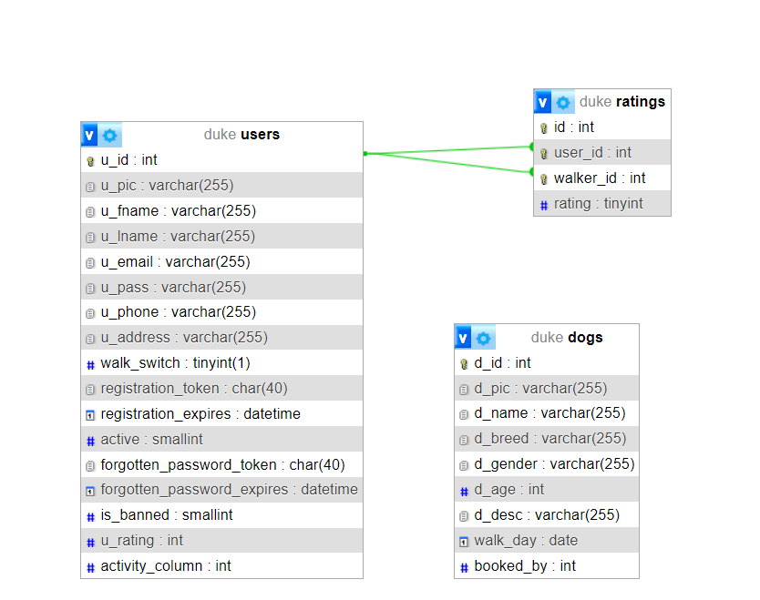

# A projekt működésének leírása

Amikor az oldalra lépünk, a lap tetején látjatjuk a gombokat, melyekre kattintva másik oldalakra vezetnek.

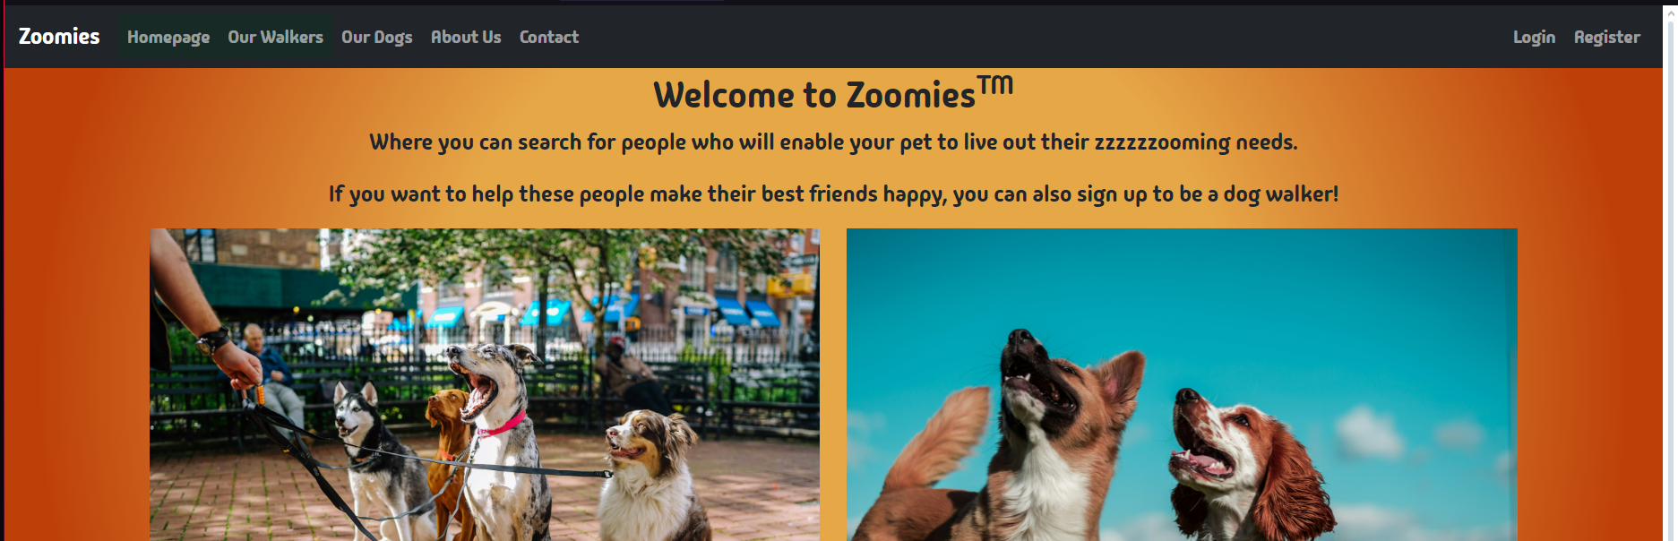

Anélkül, hogy be lennénk jelentkezve, meg tudjuk nézni az online sétáltatókat és kutyákat.

Itt fognak megjelenni a sétáltatók.

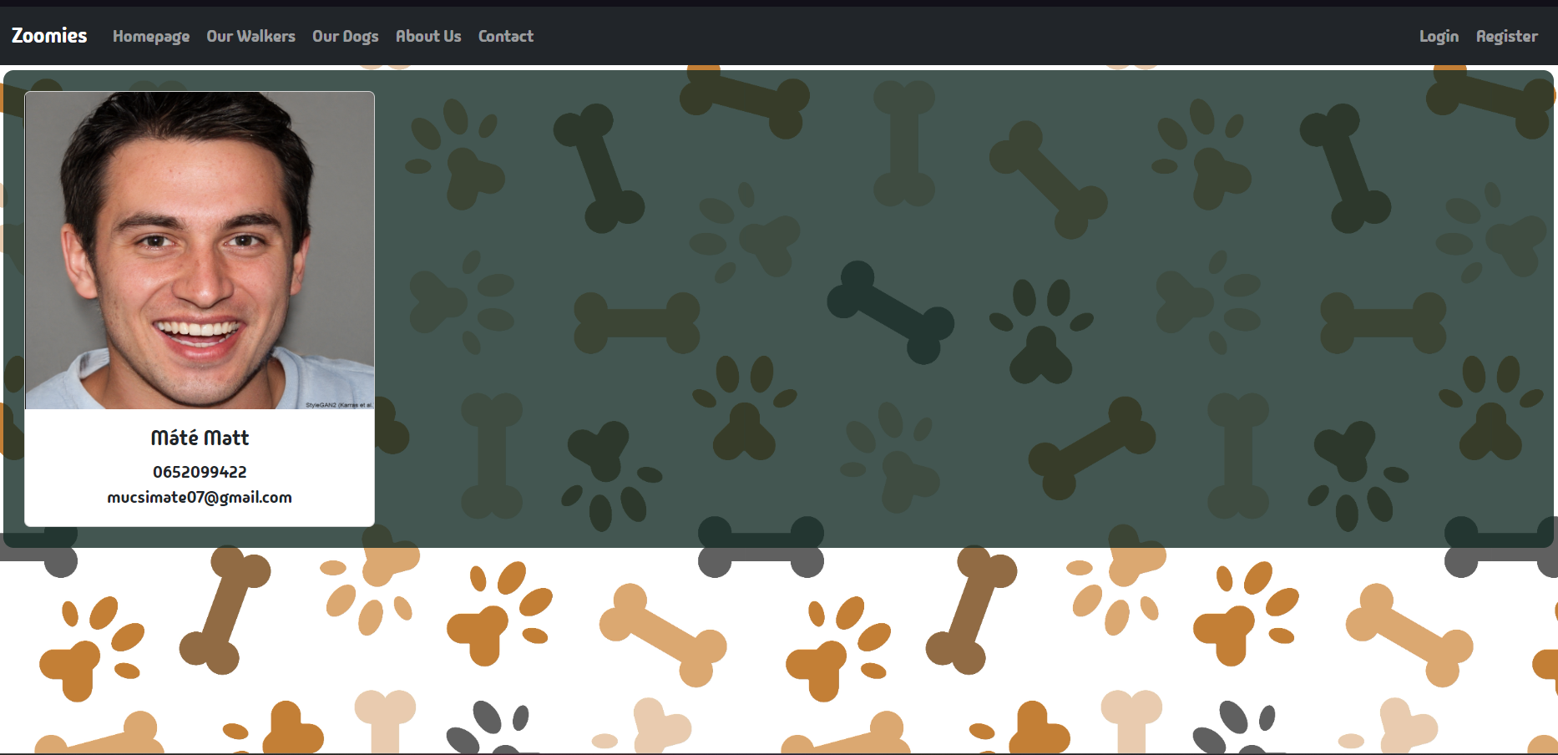

Bejelentkezés után lehetőság nyílik arra, hogy értékeljük a sétáltatót.

A kutyákat is meg tudjuk tekinteni,keresni köztük, emelett azt is hogy le vannak e foglalva vagy nem, de mast nem tudunk még nem vagyunk bejelentkezve.

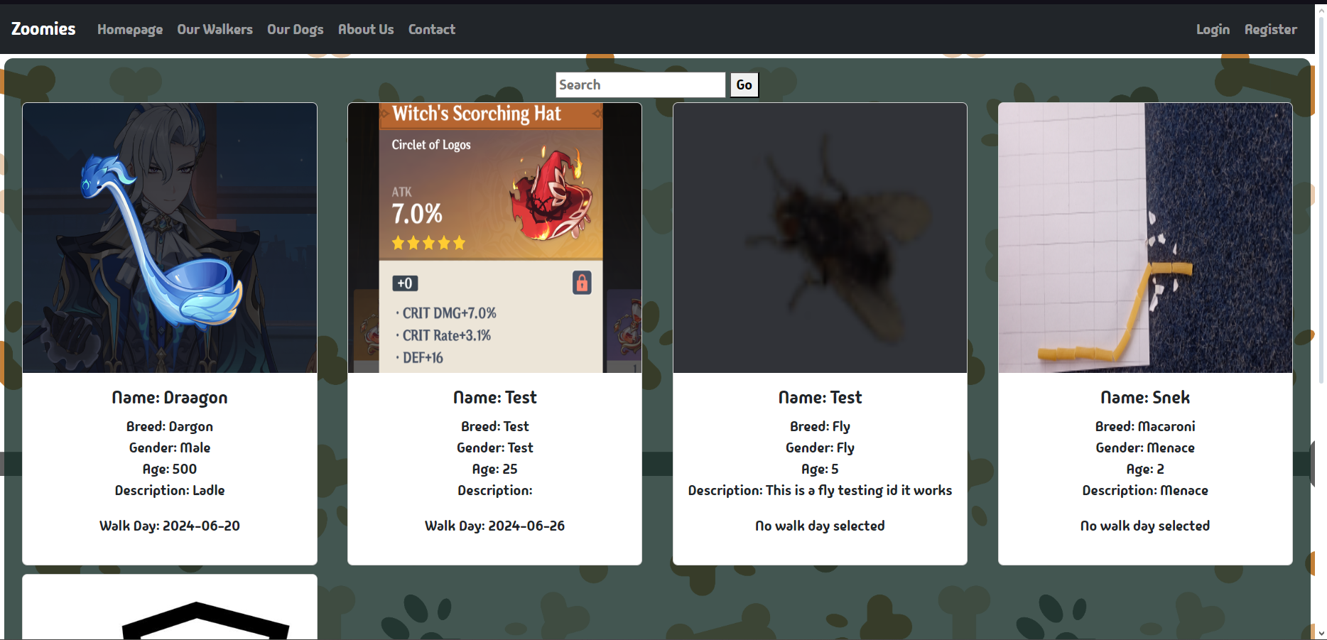

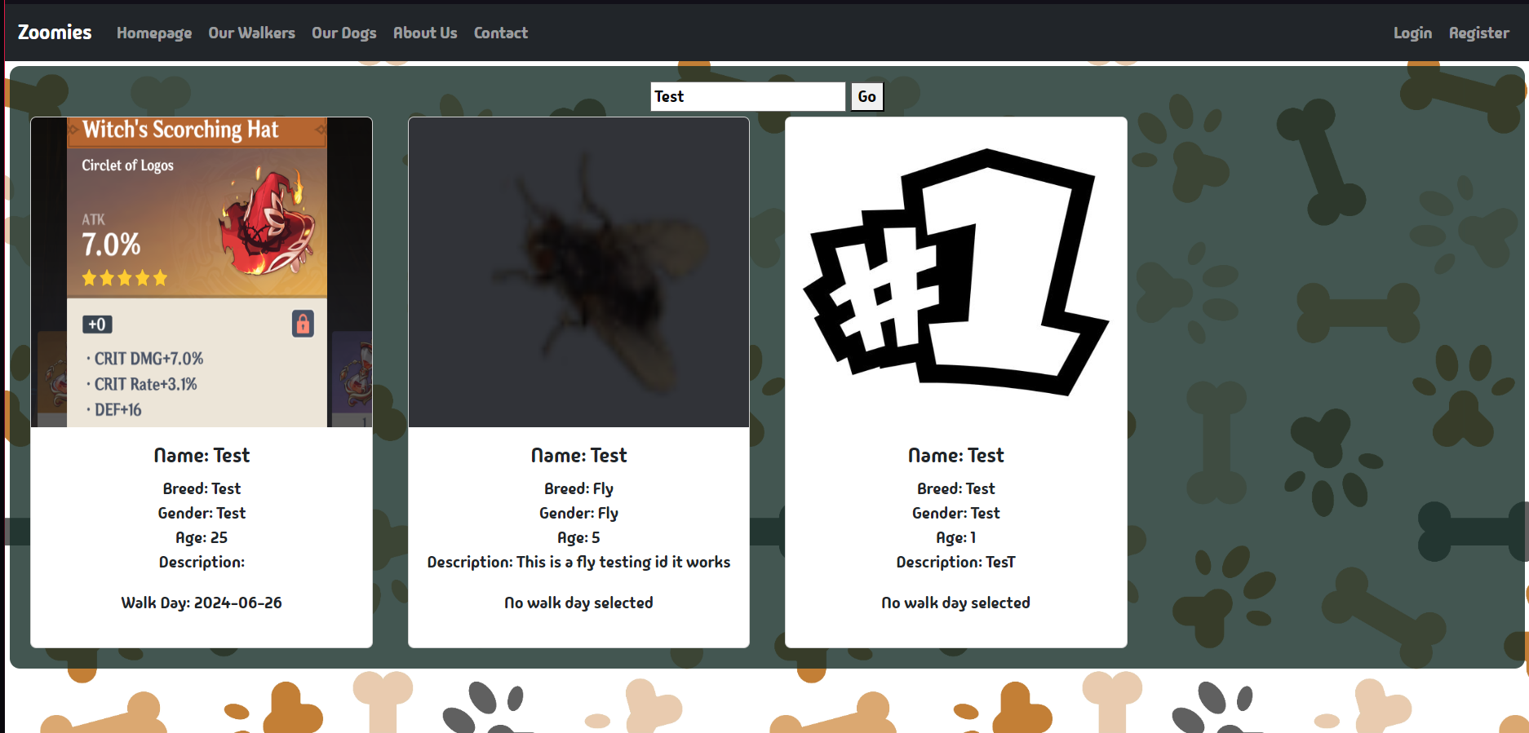

Az About Us és Contact Us oldalakon csak általános információ található a cégről és egy értékelés az oldalra.

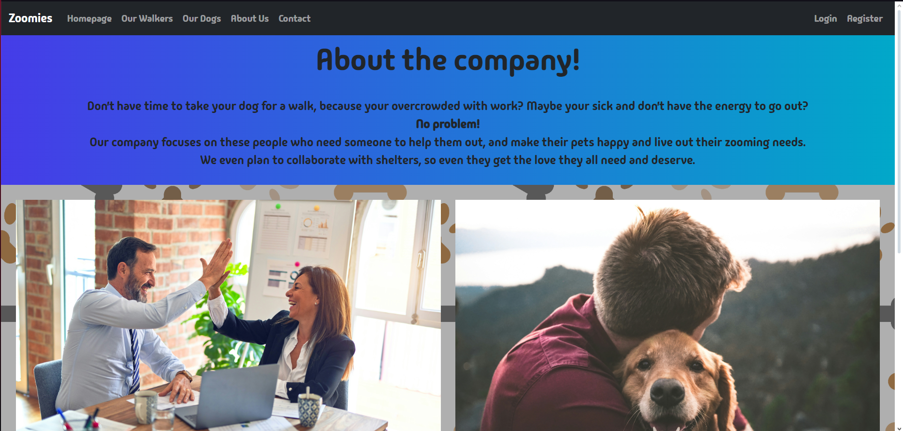

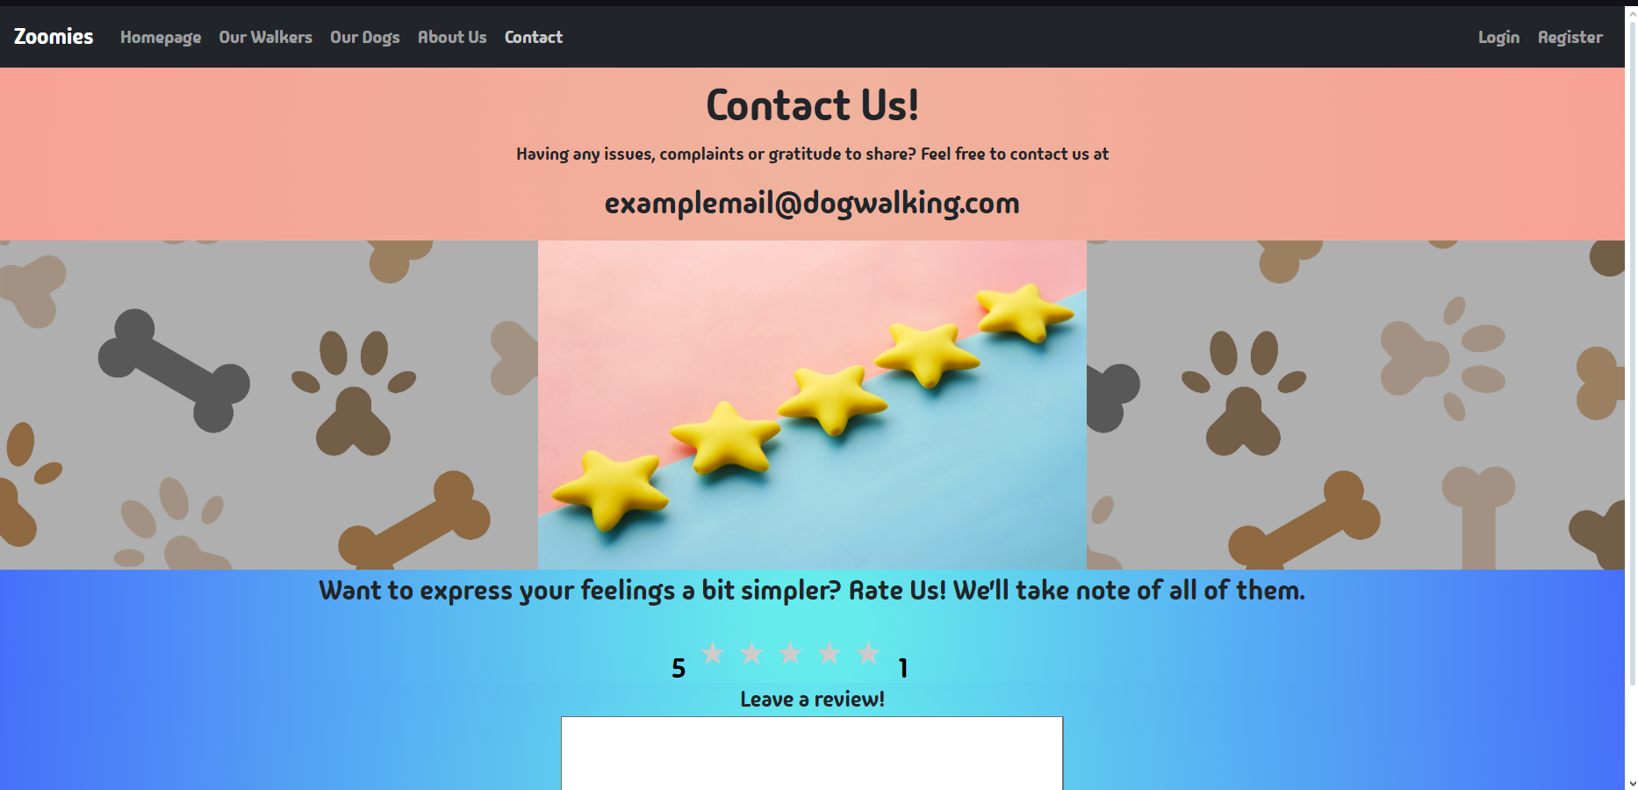

**Áttérünk a bejelntkezésre.**

**A navigávió jobb sarkában két gombot találthaunk, az egyik az Bejelentkezéshez, a másik pedig a Regisztrációhoz.**

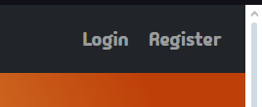

A Register oldalon 7 adattal tudunk bejelntkezni. Ezek mind ellenőrizve vannak a web.php-n belül.

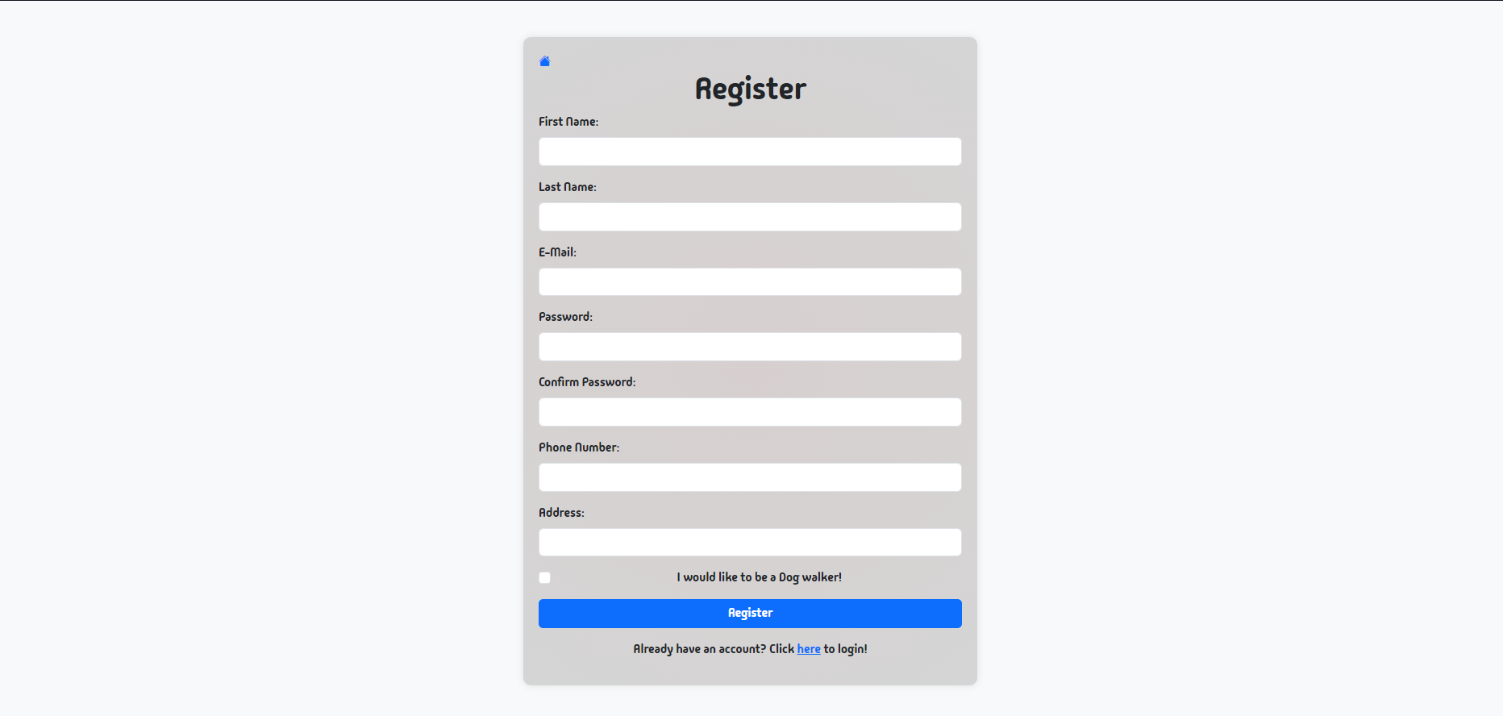

A web.php a function.php függvénytár file-ból szerzi az ellenőrző függvényeket.

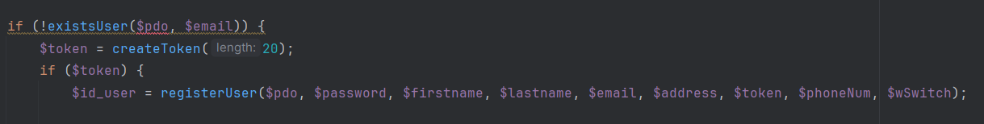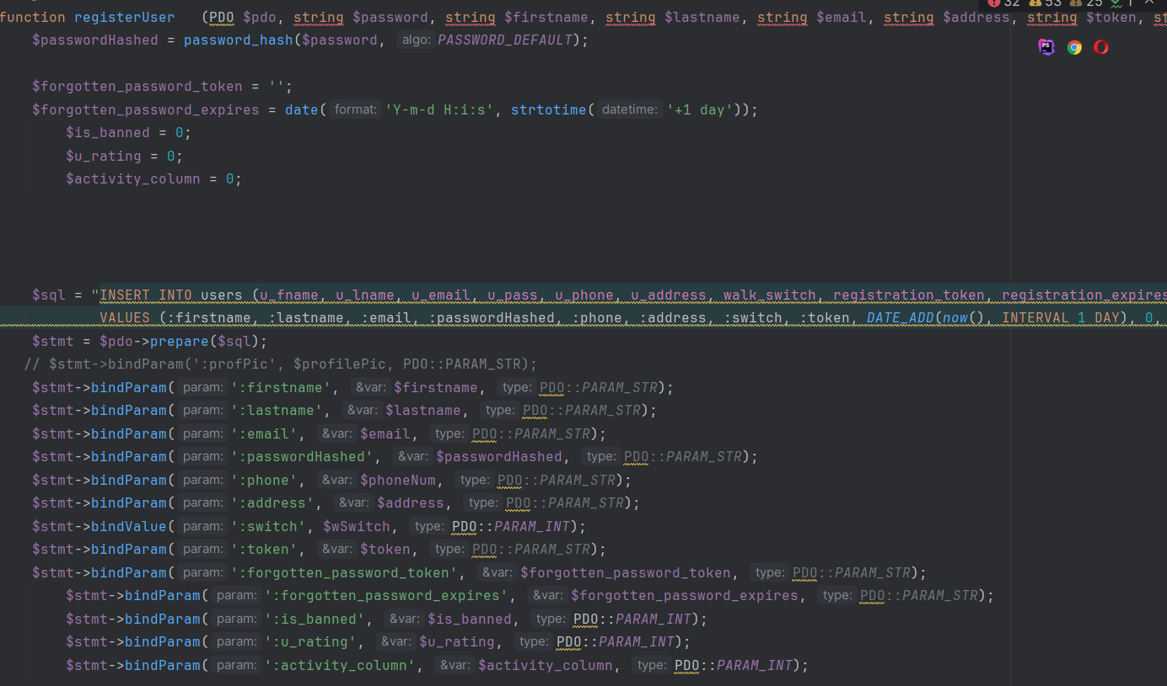

Ha szeretnénk egy fiókot készíteni, írjuk be az adatainkat. Ügyelni kell, hogy az emailnek helyes email formátumú kell legyen, emelett a jelszóra is ügyelnünk kell. Az oldal utasítani fog minket, hogy milyen kvóták szerint kell jelszót adnunk. 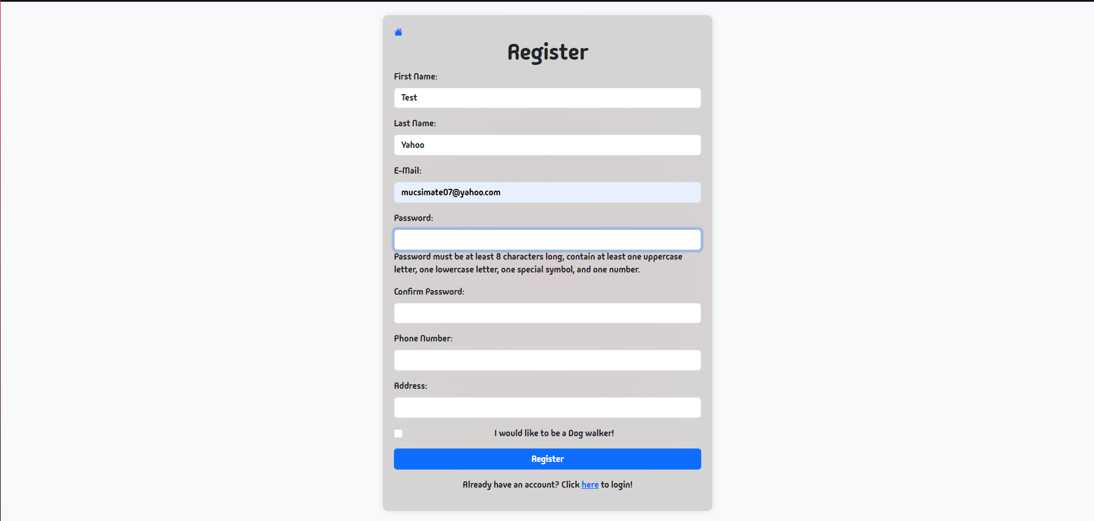

A regisztrálás gomb felett tudjuk megmondani, hogy kutyasétáltatók szeretnénk-e lenni, vagy sem. Elősször ugy csináljuk, hogy sétáltatók leszünk.



Amikor mindent kitöltöttünk, rányomhatunk a regsztrálás gombra. Ugyanitt egy kis jelzés lesz, amely szól, hogy a fiók aktiválásához az emailben találjuk a linket.

A rendszer küldött egy emailt a fent megadott mezőben megadott címre. (Érdemes a Spam fülkében is megnézni, ha nem jelenik meg az email.)

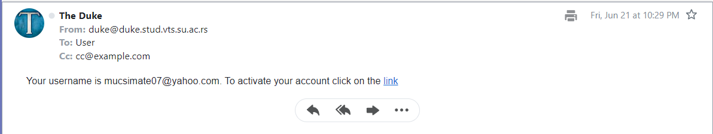

Az email küldés a PHPMailer plugin segítségével valósítható meg.

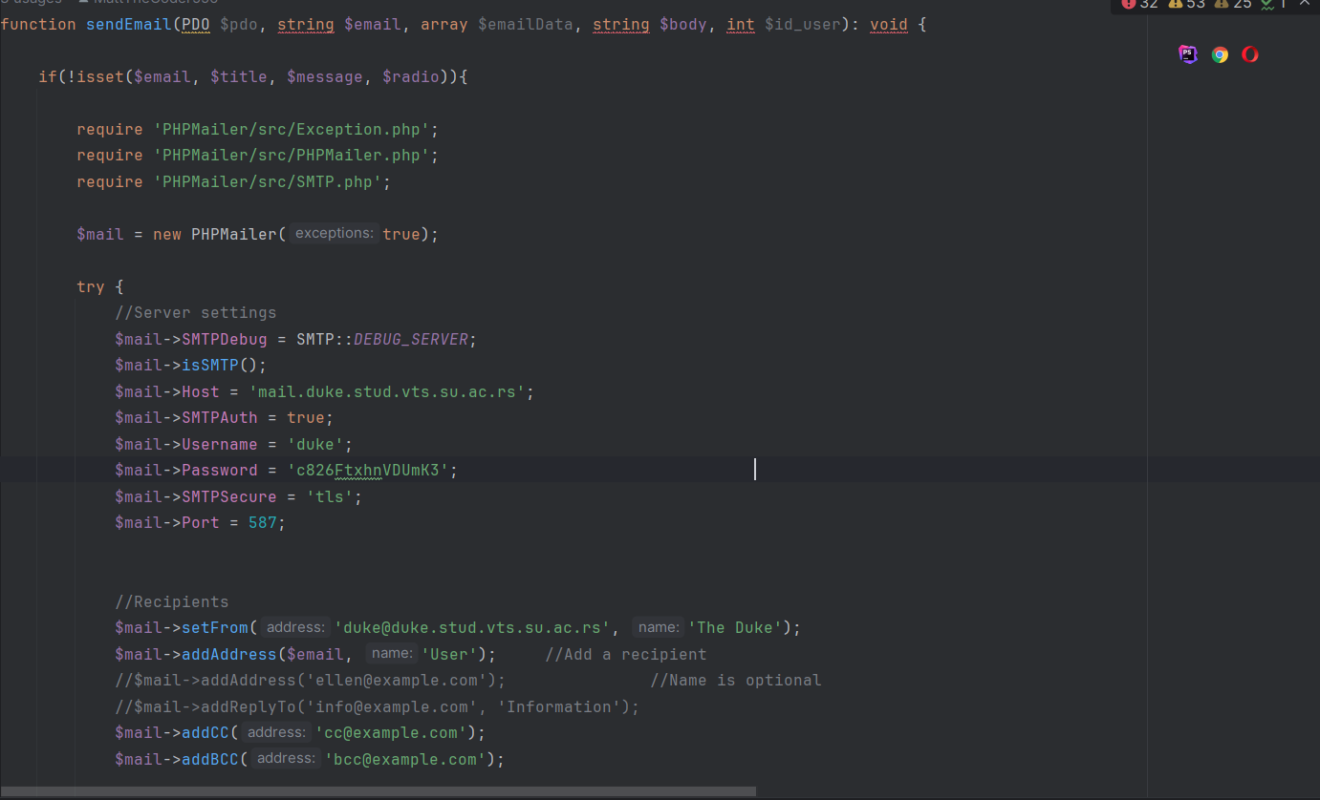

Az emailben találtható linkre kattintva aktívvá teszi a fiókót, visszaküld minket a kezdőoldalra és mostmár be tudunk jelentkezni.

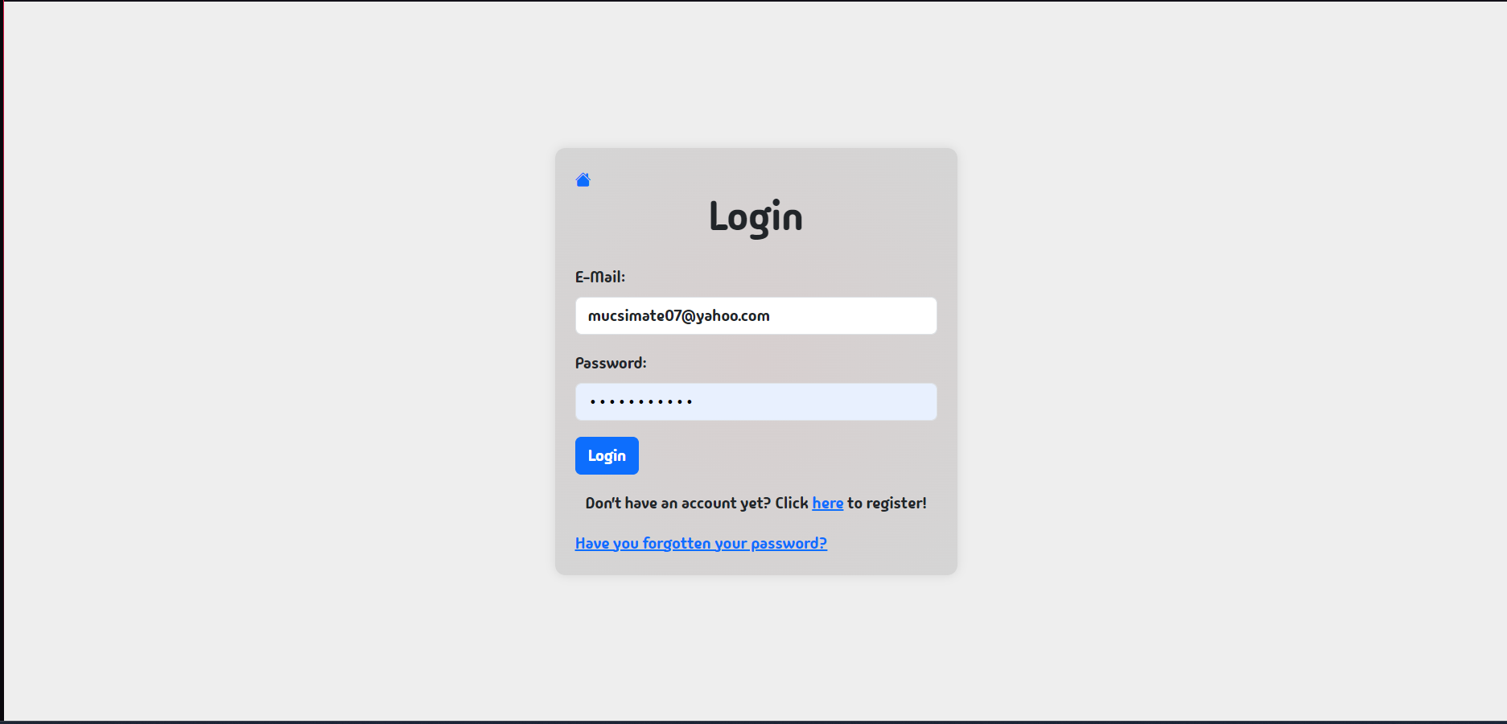

Ha véletlen elfelejtettük a jelszavunkat, akkor az also link jön szerepbe.



Itt meg tudjuk adni az emailt, amely fióknak meg kell változtatni a jelszavát.

Amikor beírtuk az emailt és megnyomtuk a gombot, visszaküld a kezdőoldalra. Közben a megadott email címre küld egy linket, ahol meg tudjuk változtatni a jelszavunkat.

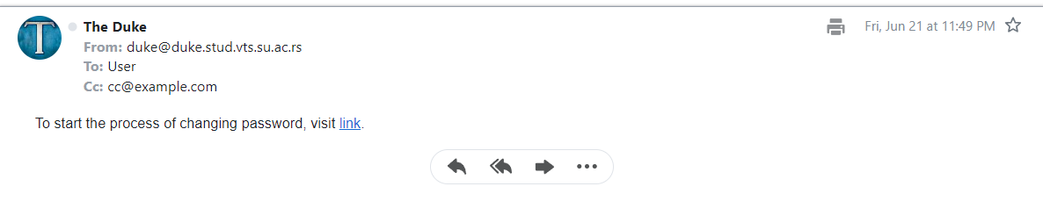

A linkre kattintva ezt az oldalt kapjuk:

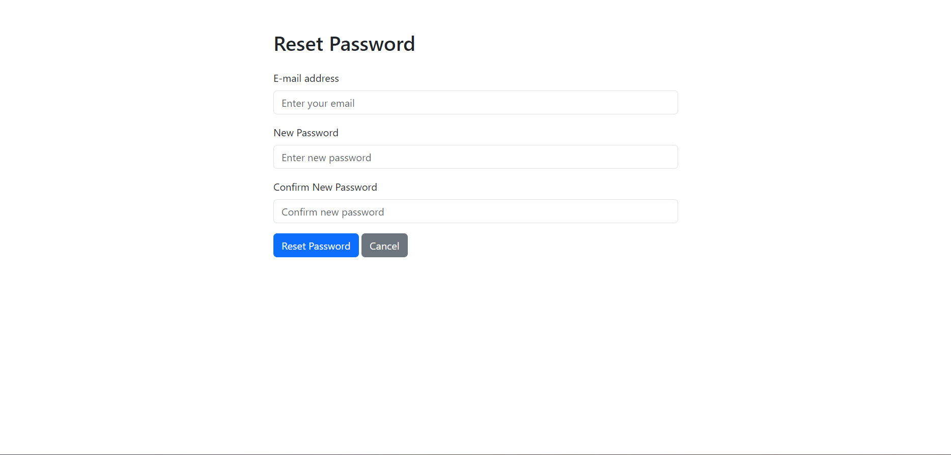

Itt be kell írnunk az emalcímet, amelynek meg szeretnénk változtatni a jelszavát, majd az új jelszót kétszer.

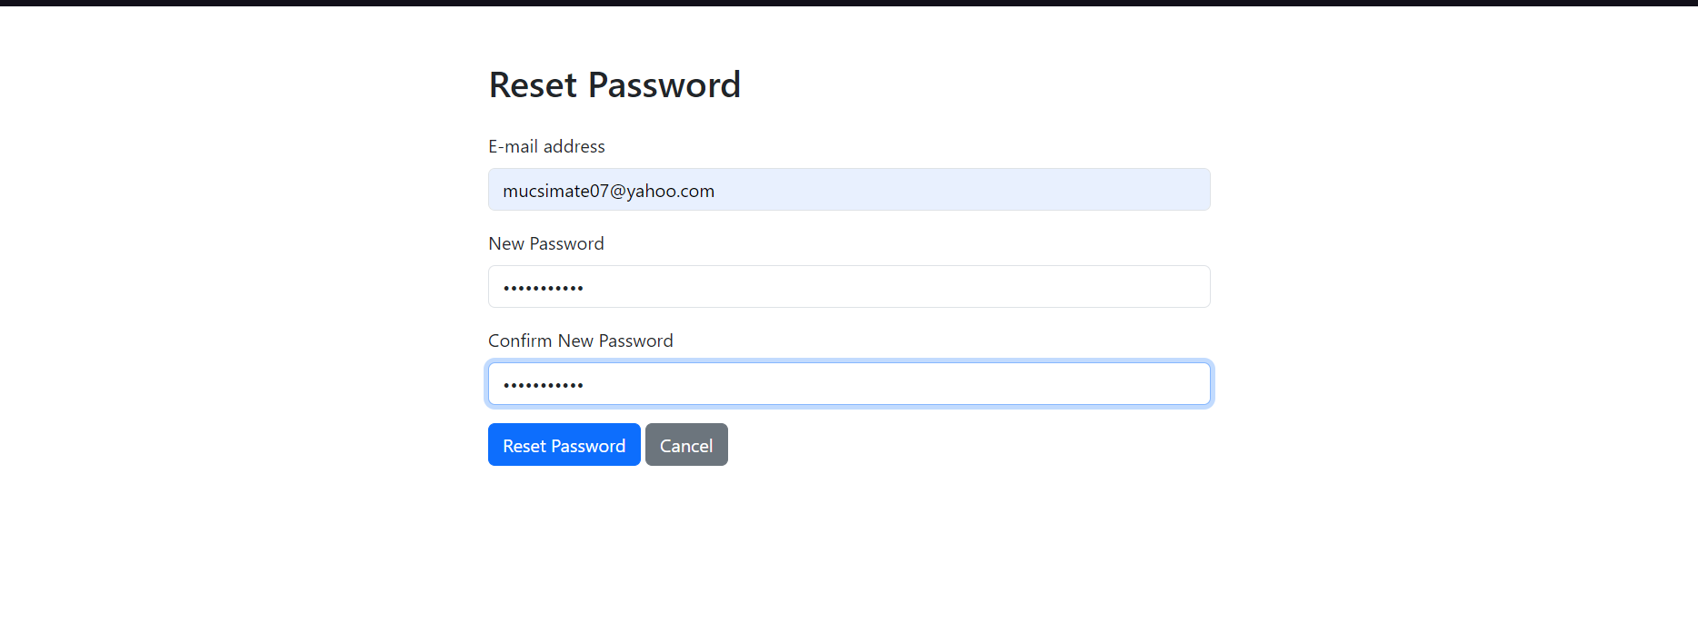

Ha kész és rányomtunk a Reset Password gombra, ezt fogjuk látni  
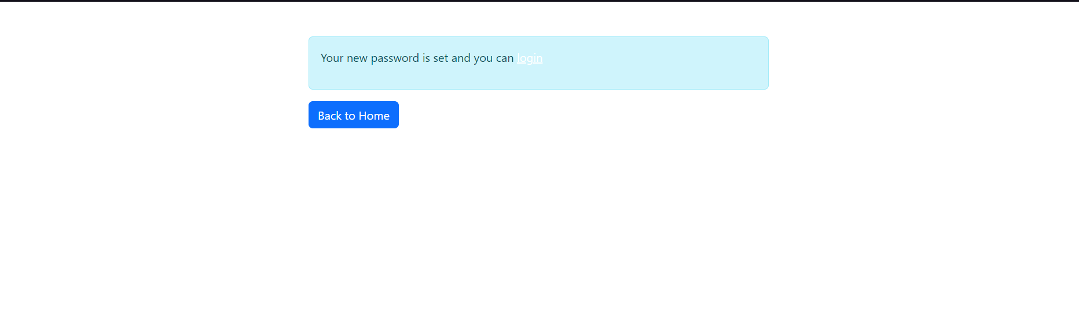

Itt visszavezet minket az index oldalra, ahol mostmár az új jelszóval be tudunk jelentkezni.

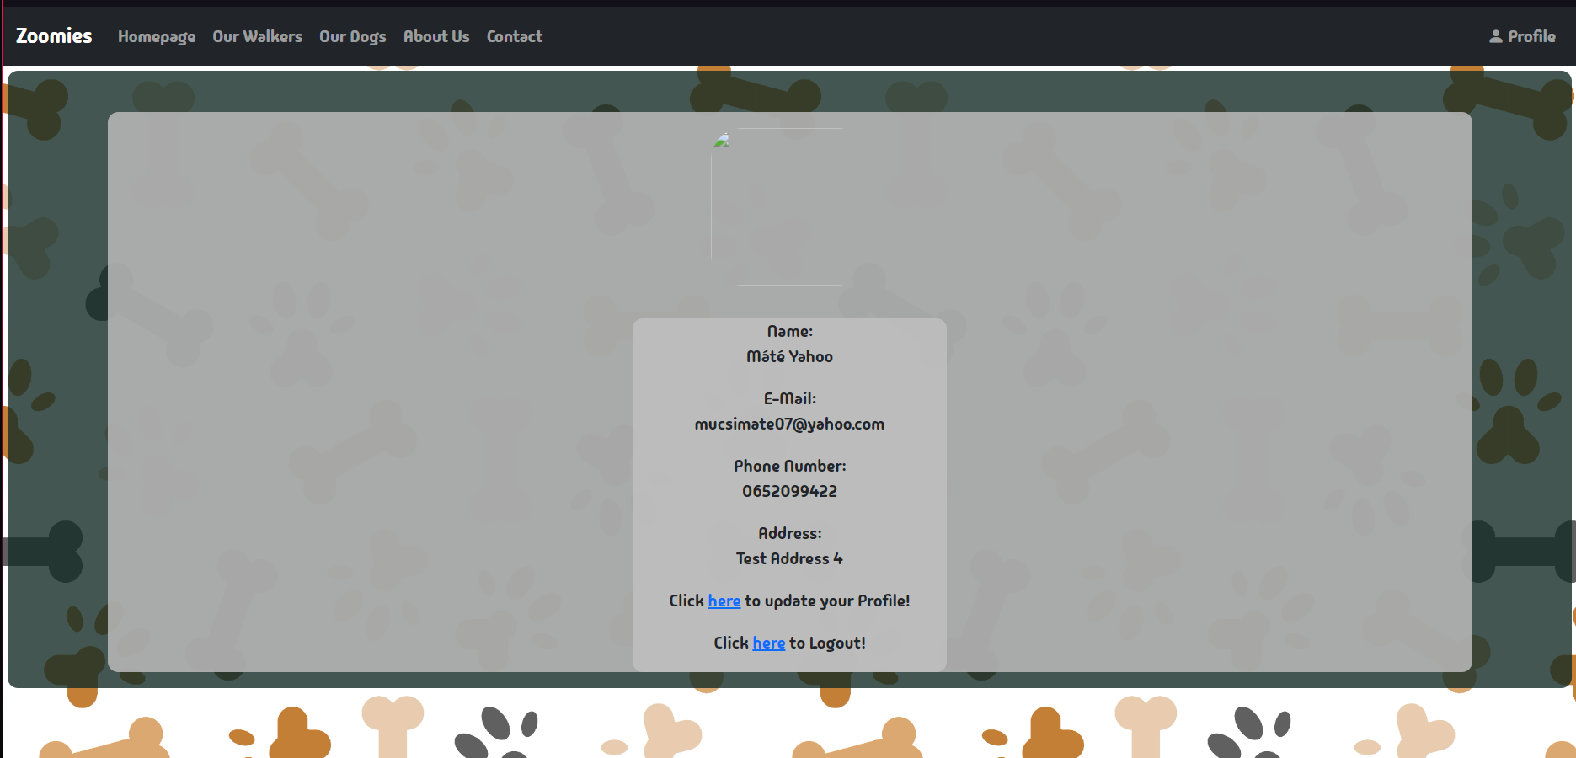

Látható, hogy ahogy bejelentkeztünk, a Regisztráció gombok helyett a profilunkhoz vezető linket találhatjuk. Emelett a bejelentkezés után rögtön oda is vezet. Itt láthatjuk minden infót melyet regisztrációkor megadtunk. Ezeket tudjuk változtatni az első link segítségével a címünk alatt.

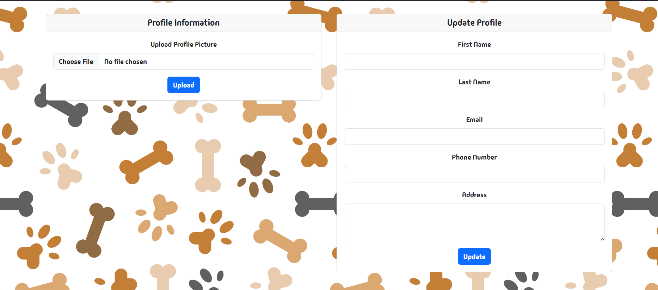

Ezt a fiókunk frissítő űrlapjai. Itt tudunk profilképet is megadni magunkról, amelyet bármikor le tudunk cserélni.

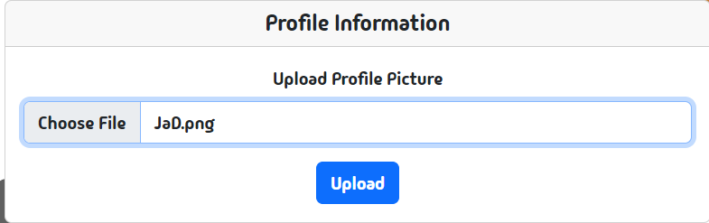

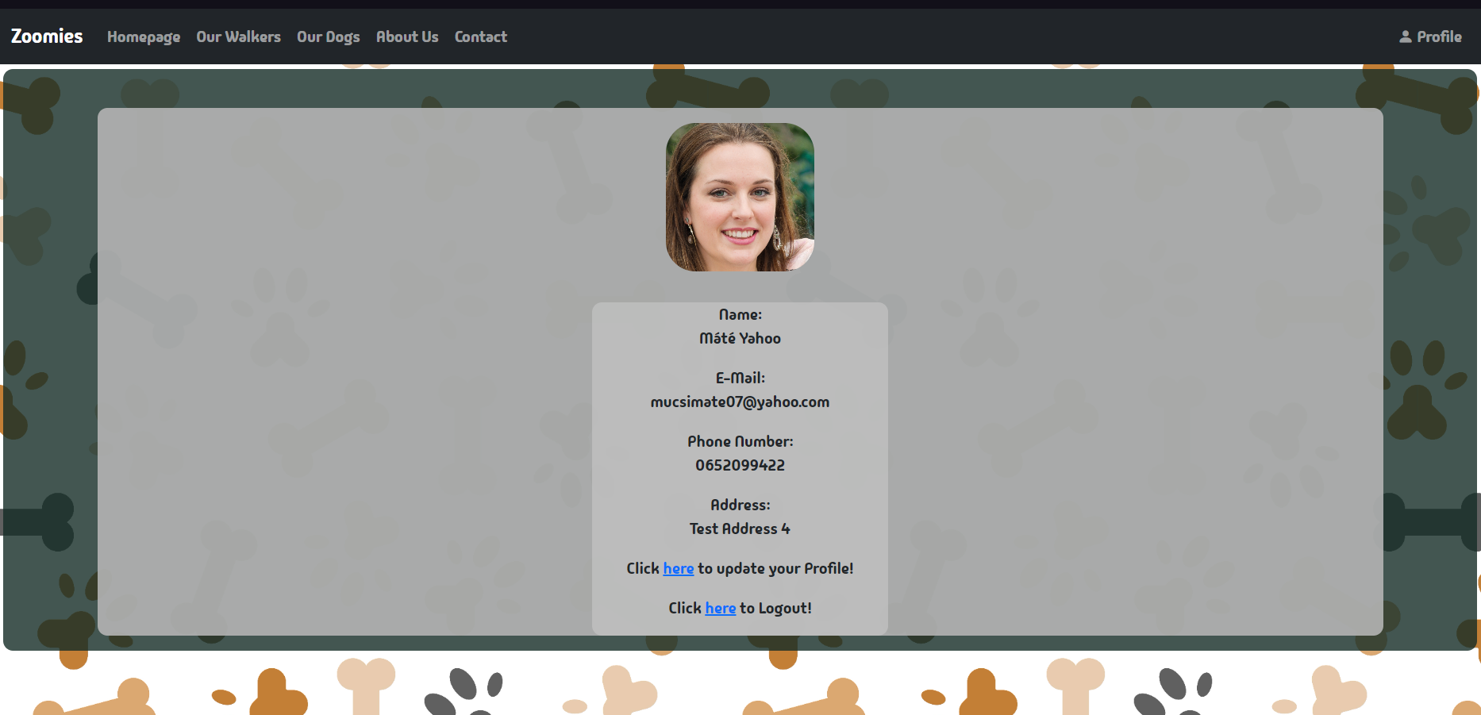

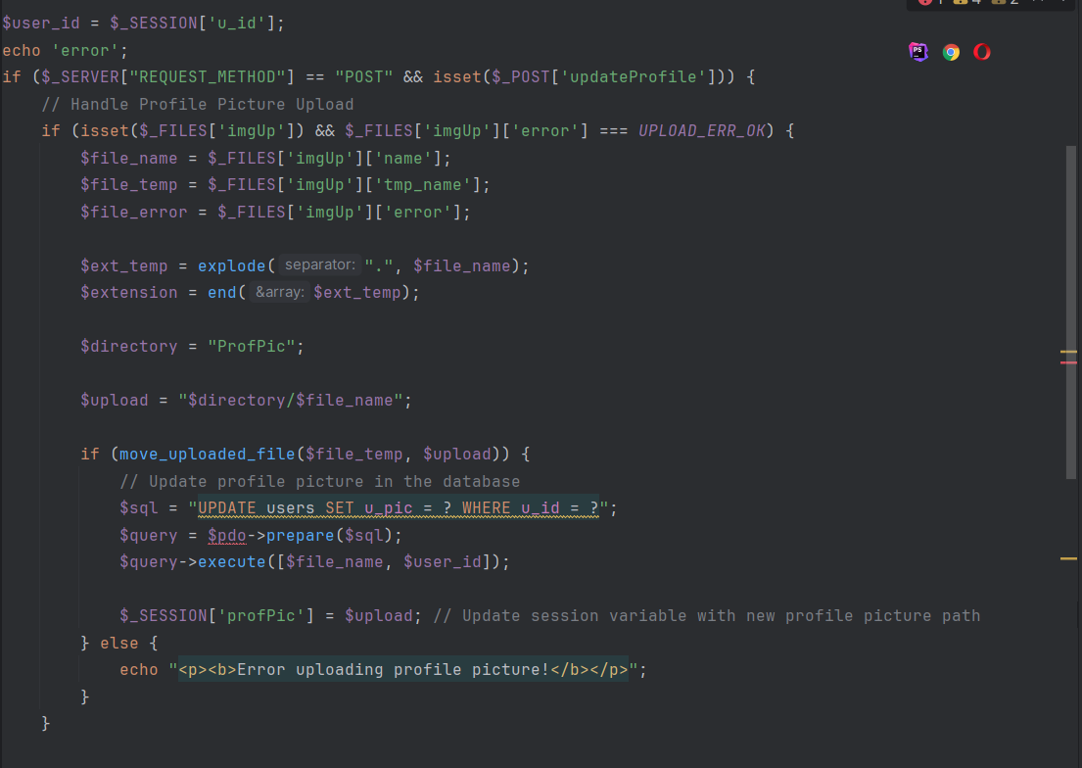

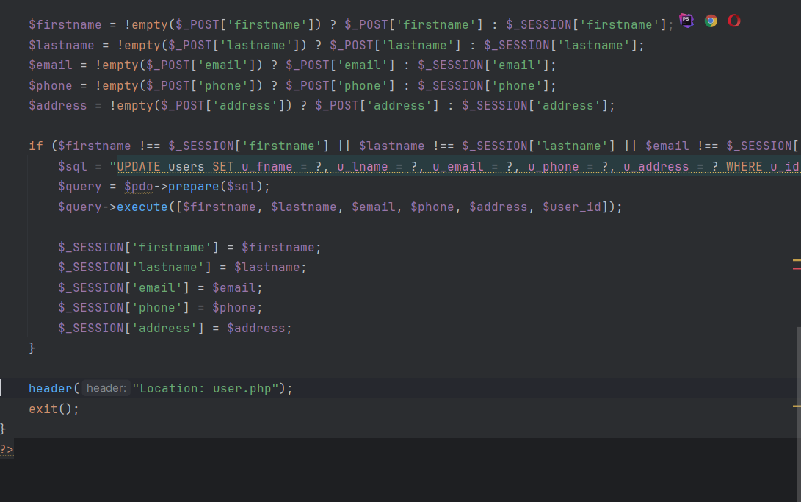

Egyszerűen be is állítottuk a profilképünket. Mivel kutyasétáltatóként jelentkeztünk be, meg is tudjuk nézni a sétáltatók oldalát, ahol magunkat is megtaláljuk.

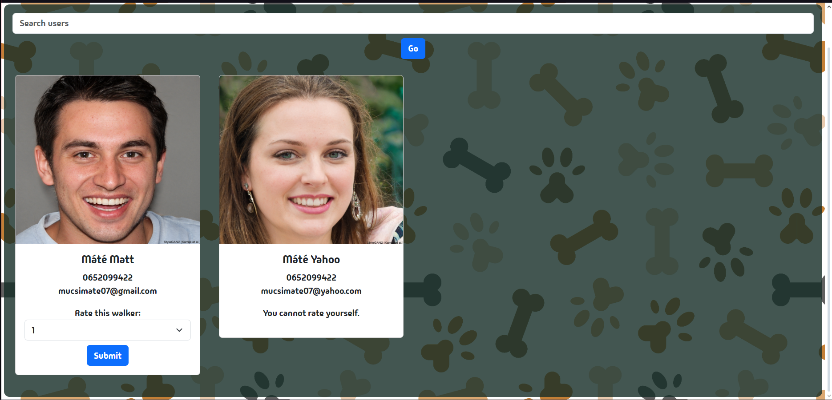

Mostmár, mivel be vagyunk jelentkezve, láthatjuk, hogy tudjuk értékelni a többi kutyasétáltatót, ha volt velük interakciónk. Értékelni egyvalakit csak egyszer tudunk. Emelett tudunk keresni is, ha fel szeretnénk keresni ugyan azt a sétáltatót.

Ha értékeltünk rögtön el is veszi tőlünk a lehetőséget több értékestől.



Másik nagy változás, a kutyák oldalán történt.

Mostmár van lehetőségünk kiválasztani a kutyát, akit szeretnénk vinni sétáltatni.

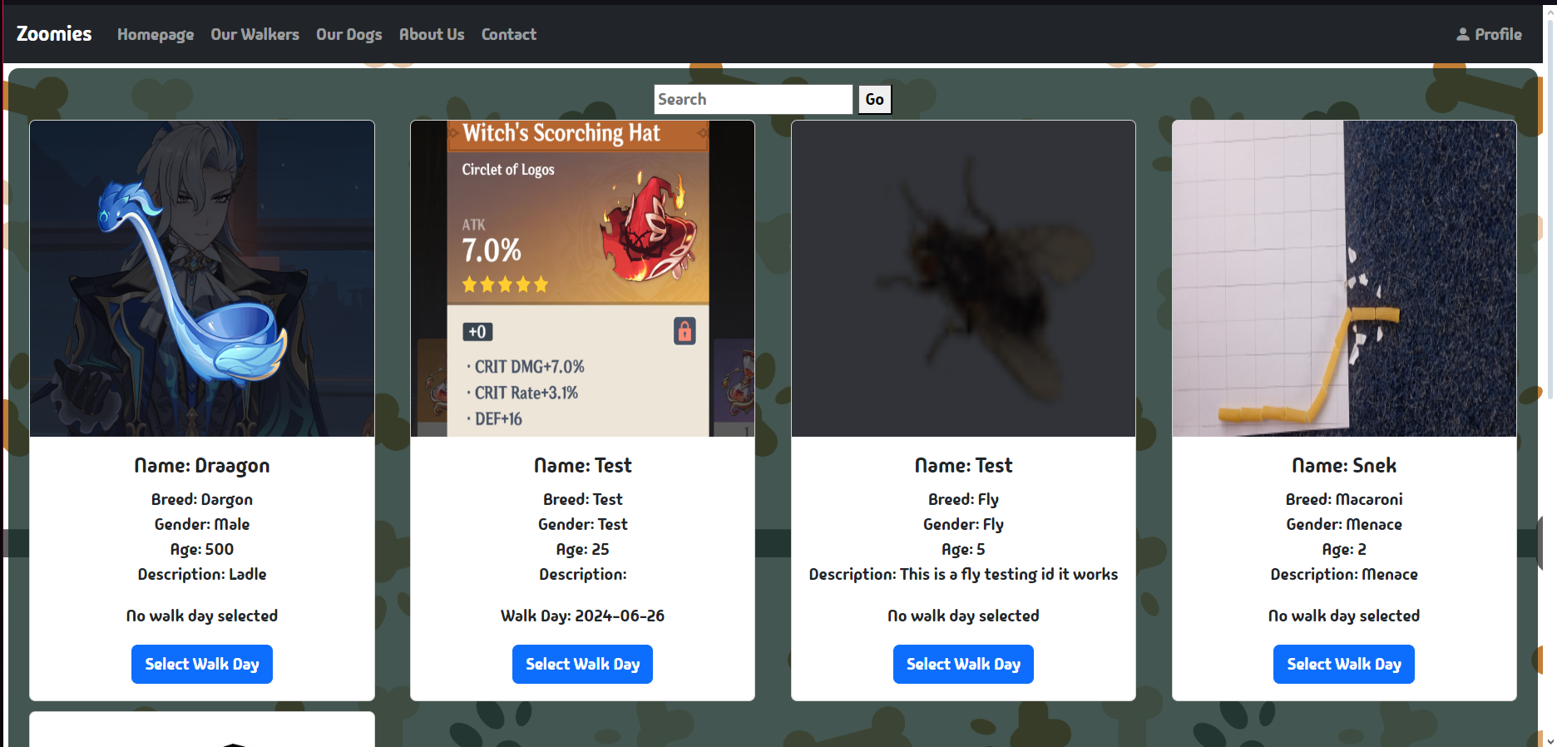

A Select Walk Day gombra rányomva előjön egy menü, ahol ki tudjuk választani, hogy melyik nap visszük sétálni a kutyát.

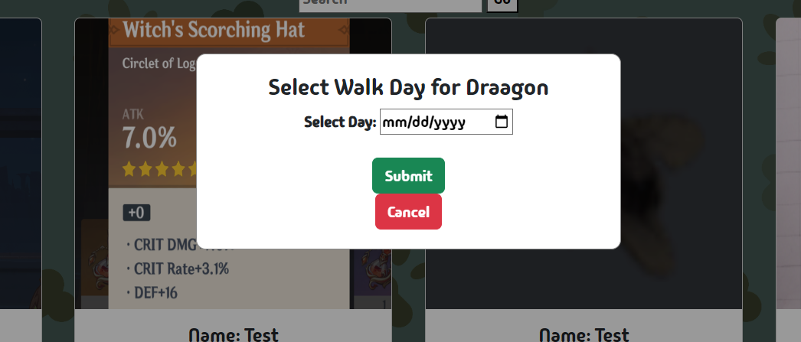

Amikor kiválasztottuk, az oldal megerősíti, hogy ki lett választva és le lett foglalva a kutya.  
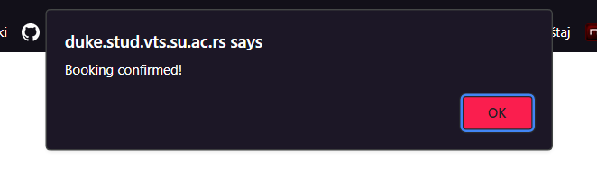

Ha rányomunk az OK-ra, visszavezet minket a kutyák oldalára, ahol látható hogy melyik kutyát választottam ki.

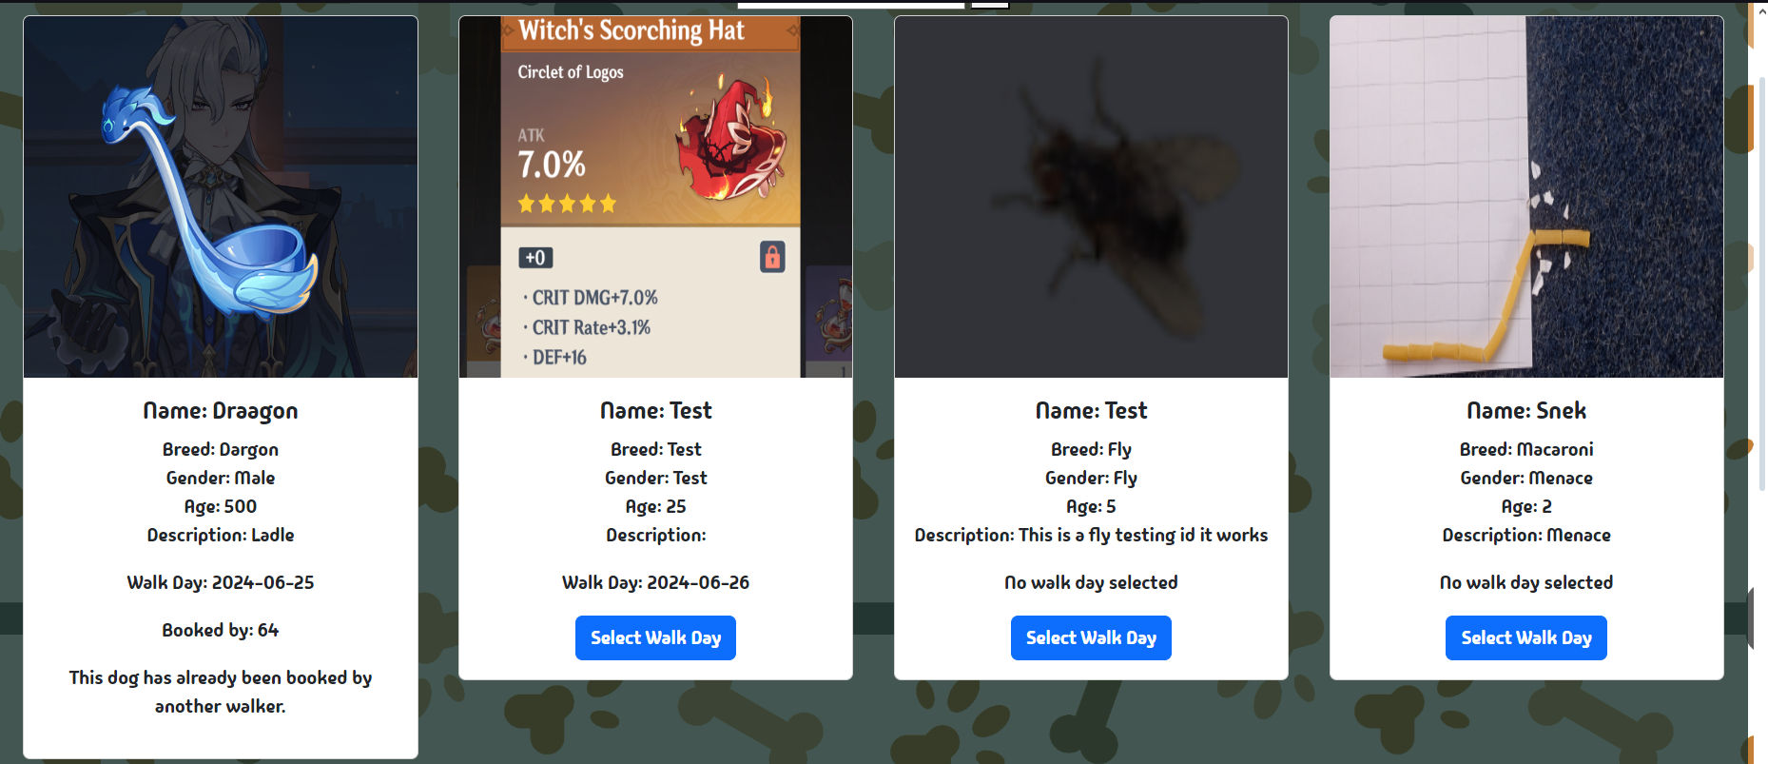

Ezt azt jelenti, hogy amíg nem múlik el a nap, amikor sétáltatom ezt a kutyát, addig más nem tudja lefoglalni.

Ezt a proces_walk_day.php segítségével lett megoldva.  
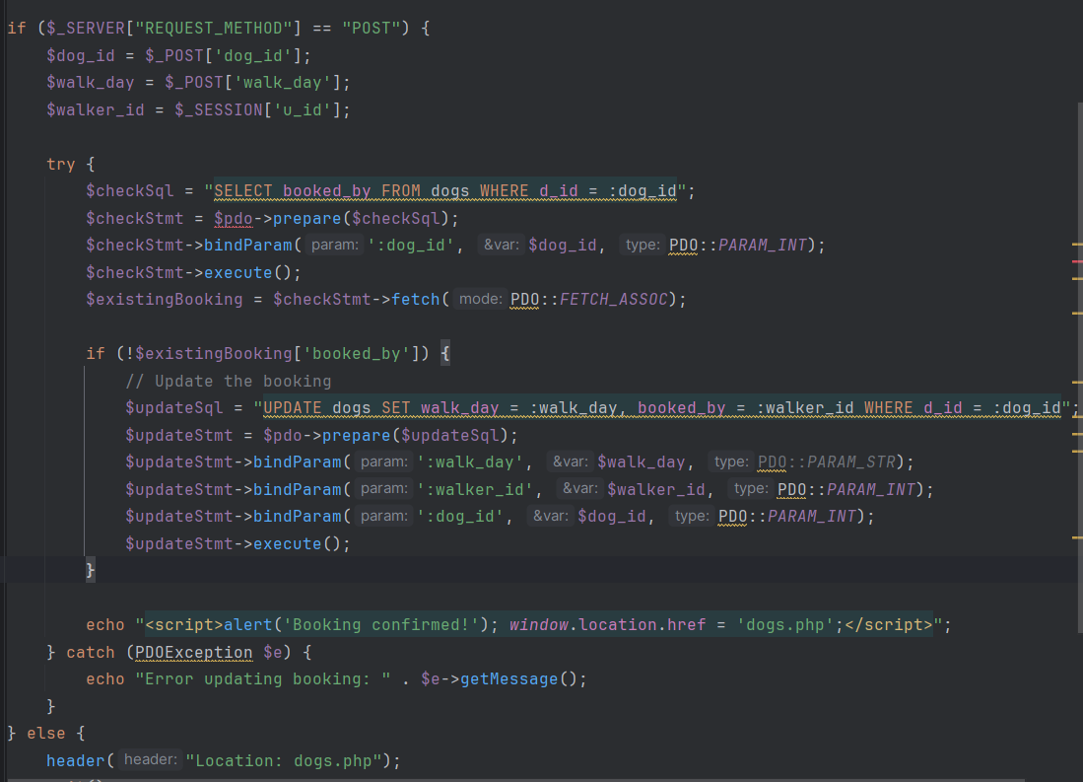

Ha szeretnénk kutyát hozzáadni a listához, hogy emberek nyugodtan vigyék sétáltatni, az oldal legaljára kell pillantanunk.

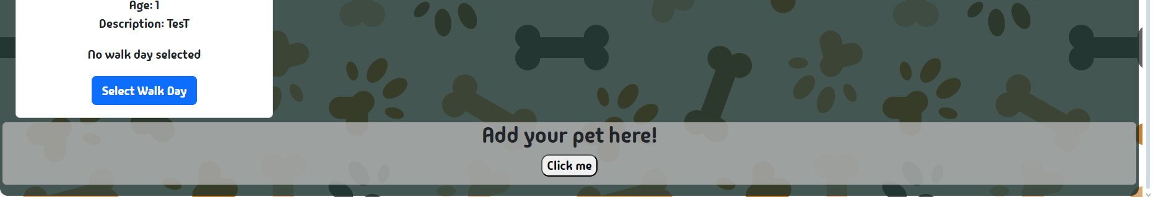

Erre a kis gombocskára nyomva egy űrlapot kapunk, ahol meg tudjuk adni a kutya összes adatát.

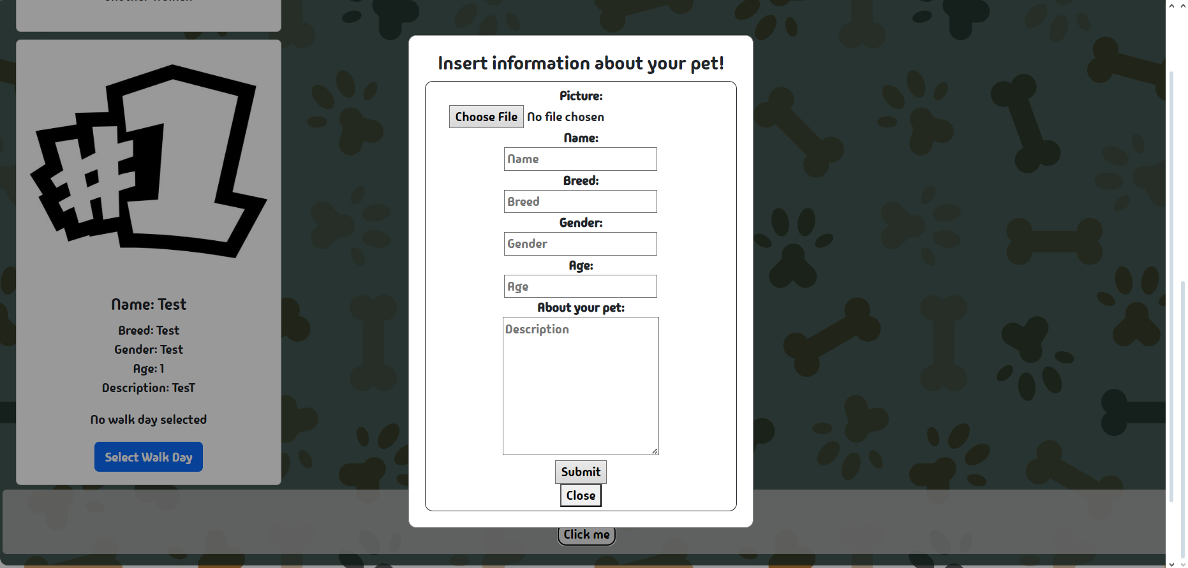

Ha készen vagyunk, a Submit gombra nyomunk és már fel is került a kiskedvencünk az internetre.

Az admin beállításokat is el tudjuk érni, ha tudjuk mi a titkos jelszó :).

(Az admin elérést egyszerű string ellenőrzésként van megcsinálva, admin az email, admin a jelszó).

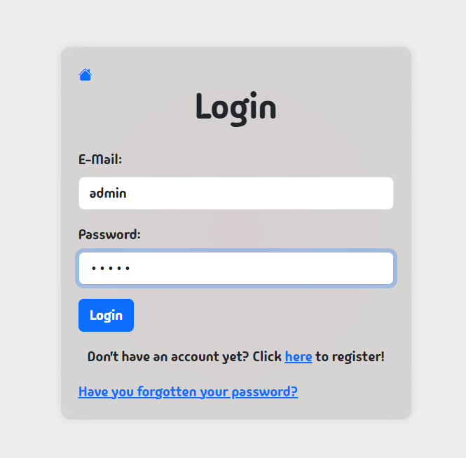

Innen egy egyszerű HTML lapon találjuk magunk 2 linkkel, amely a két fő tábla admin felületéhez vezet.  
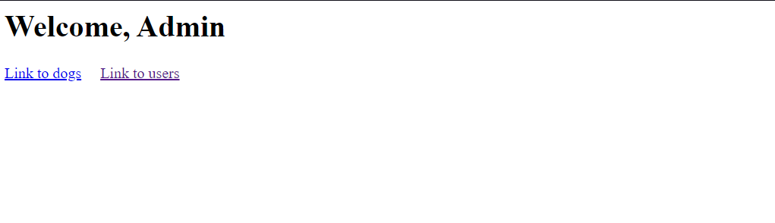

A kutyák admin felülete:

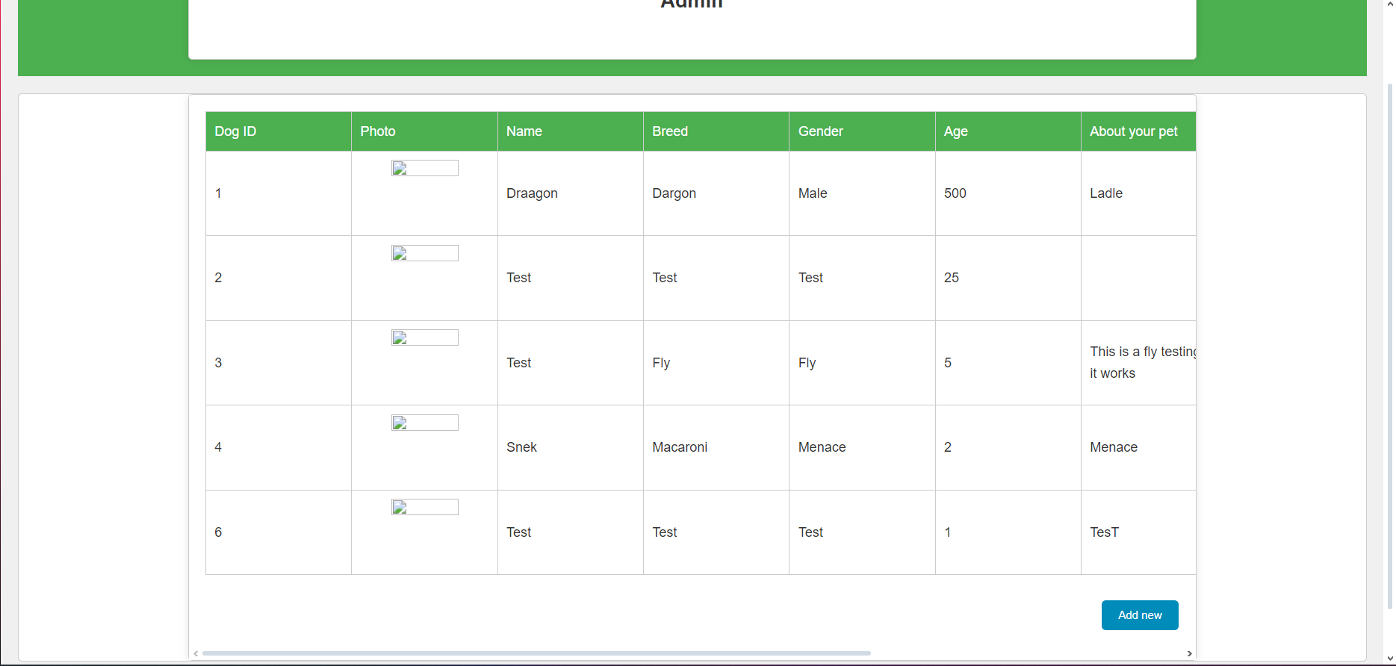

Itt tudjuk az összes kutya adatát állítani, emelett törölni és hozzáadni újjat manuálisan.

Ugyan ez a felhasználokkal:  
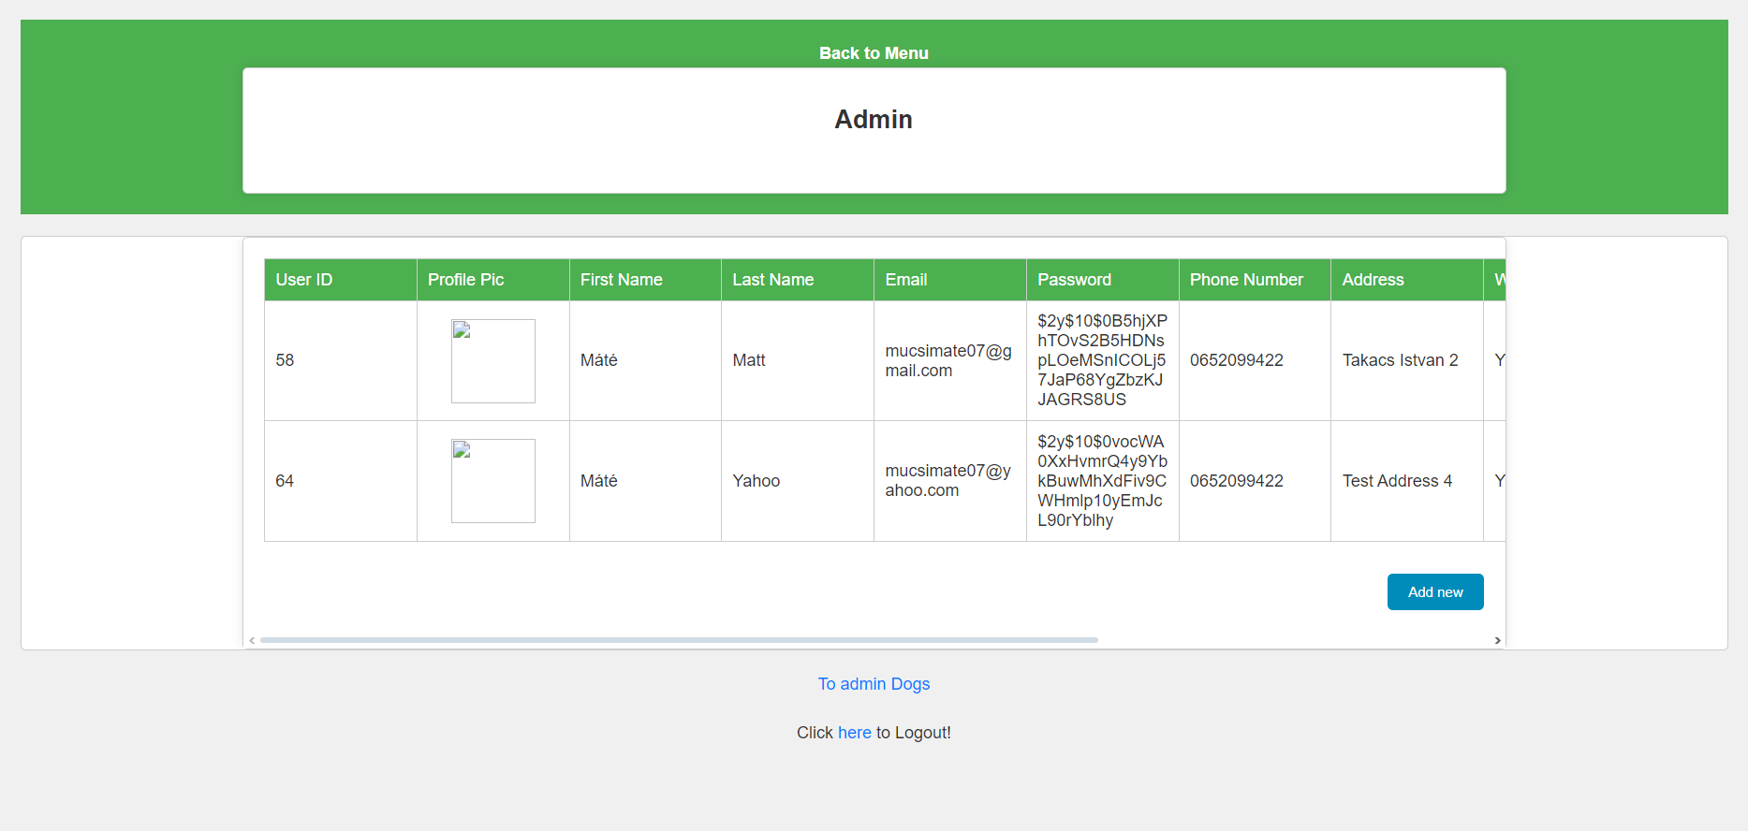

# Felhasznált irodalom

W1. <http://www.w3schools.com/>

W2. <http://www.jquery.com>

W3. <https://stackoverflow.com>

W4. <https://cssgradient.io>

W5. <https://unsplash.com>